CR-05 - Goals and Outcomes
Progress the jurisdiction has made in carrying out its strategic plan and its action plan. 91.520(a)
This could be an overview that includes major initiatives and highlights that were proposed and executed throughout the program year.

The City of Sterling Heights received a CDBG Grant in the amount of $716,925. In Addition, $592,820 in carry over funds and $31,399 in program income from the Home and Property Improvement Program in repaid rehabilitation loans was received for the total program budget of $1,341,144. All program income is targted for the Home and Property Improvement Program. All resources identified in the 2017 2018 Annual Plan were pursued.
Each year the City of Sterling Heights, as a HUD designated entitlement community, complies and publishes an annual report detailing the utilization of the City's Consolidated Plan grant funds and associated accomplishments. This report is know as the Consolidated Annual Performance and Evaluation Report (CAPER) and corresponds to the priorities identified in the five-year Consulidated Plan

Comparison of the proposed versus actual outcomes for each outcome measure submitted with the consolidated plan and explain, if applicable, why progress was not made toward meeting goals and objectives. 91.520(g)
Categories, priority levels, funding sources and amounts, outcomes/objectives, goal outcome indicators, units of measure, targets, actual outcomes/outputs, and percentage completed for each of the grantee’s program year goals.

Goal | Category | Source / Amount | Indicator | Unit of Measure | Expected – Strategic Plan | Actual – Strategic Plan | Percent Complete | Expected – Program Year | Actual – Program Year | Percent Complete
Address Post-Foreclosure Housing Crisis Needs | Affordable Housing  Public Housing | CDBG: $ | Other | Other | 1 | 0 | 0.00% | 1 | 0 | 0.00%
Address the Needs of Homeless & At-Risk Families | Affordable Housing  Public Housing  Homeless | CDBG: $ | Public Facility or Infrastructure Activities other than Low/Moderate Income Housing Benefit | Persons Assisted | 0 | 180 |  | 0 | 180
Address the Needs of Homeless & At-Risk Families | Affordable Housing  Public Housing  Homeless | CDBG: $ | Public service activities other than Low/Moderate Income Housing Benefit | Persons Assisted | 0 | 15 |  | 0 | 15
Address the Needs of Homeless & At-Risk Families | Affordable Housing  Public Housing  Homeless | CDBG: $ | Homeless Person Overnight Shelter | Persons Assisted | 0 | 195 |  | 0 | 195
Address the Needs of Homeless & At-Risk Families | Affordable Housing  Public Housing  Homeless | CDBG: $ | Overnight/Emergency Shelter/Transitional Housing Beds added | Beds | 0 | 0 |  | 0 | 0
Address the Needs of Homeless & At-Risk Families | Affordable Housing  Public Housing  Homeless | CDBG: $ | Other | Other | 1 | 0 | 0.00% | 1 | 0 | 0.00%
Expand Comprehensive Planning, Management and Cap | Affordable Housing  Public Housing  Homeless  Non-Homeless Special Needs  Non-Housing Community Development | CDBG: $ | Other | Other | 1 | 0 | 0.00% | 1 | 0 | 0.00%
Foster Economic Development | Non-Housing Community Development | CDBG: $ | Public service activities other than Low/Moderate Income Housing Benefit | Persons Assisted | 0 | 12 |  | 0 | 12
Foster Economic Development | Non-Housing Community Development | CDBG: $ | Other | Other | 1 | 0 | 0.00% | 1 | 0 | 0.00%
Improve Public Facilities and Infrastructure | Non-Housing Community Development | CDBG: $ | Public Facility or Infrastructure Activities other than Low/Moderate Income Housing Benefit | Persons Assisted | 0 | 4106 |  | 0 | 4106
Improve Public Facilities and Infrastructure | Non-Housing Community Development | CDBG: $ | Other | Other | 1 | 0 | 0.00% | 1 | 0 | 0.00%
Make Available Appropriate Housing | Affordable Housing  Public Housing | CDBG: $ | Other | Other | 1 | 0 | 0.00% | 1 | 0 | 0.00%
Provide and Expand Human Services | Affordable Housing  Public Housing  Homeless  Non-Homeless Special Needs  Non-Housing Community Development | CDBG: $ | Public Facility or Infrastructure Activities other than Low/Moderate Income Housing Benefit | Persons Assisted | 0 | 240 |  | 0 | 240
Provide and Expand Human Services | Affordable Housing  Public Housing  Homeless  Non-Homeless Special Needs  Non-Housing Community Development | CDBG: $ | Public service activities other than Low/Moderate Income Housing Benefit | Persons Assisted | 0 | 158 |  | 0 | 158
Provide and Expand Human Services | Affordable Housing  Public Housing  Homeless  Non-Homeless Special Needs  Non-Housing Community Development | CDBG: $ | Homeless Person Overnight Shelter | Persons Assisted | 0 | 221 |  | 0 | 221
Provide and Expand Human Services | Affordable Housing  Public Housing  Homeless  Non-Homeless Special Needs  Non-Housing Community Development | CDBG: $ | Overnight/Emergency Shelter/Transitional Housing Beds added | Beds | 0 | 0 |  | 0 | 0
Provide and Expand Human Services | Affordable Housing  Public Housing  Homeless  Non-Homeless Special Needs  Non-Housing Community Development | CDBG: $ | Other | Other | 1 | 0 | 0.00% | 1 | 0 | 0.00%
Table 1 - Accomplishments – Program Year & Strategic Plan to Date

Assess how the jurisdiction’s use of funds, particularly CDBG, addresses the priorities and specific objectives identified in the plan, giving special attention to the highest priority activities identified.
The total number of residents served:
- Extremely low income was approximately 742 people/households served.
- Low income was approximately 881 people/households served.
Improve Public Facilities and Infrastructure Community and stakeholder feedback indicate a need for public works and improvements throughout the City. The public demands that facilities and infrastructure be maintained and installed as appropriate to meet existing and increased needs. The City used funds to improve an existing City Senior Center, including replacement of carpeting, replacement of operable partition walls, replacement of the sidewalk and parking lot. Make Available Appropriate Housing The maintenance and preservation of housing for all residents but particularly affordable housing for LI owners and renters is a high priority of this Plan. Newly homeless, and at-risk, families require assistance to maintain their dignity and preserve what has become a tenuous grip in the economic mainstream. Families face economic uncertainty due to stagnant or declining incomes resulting from un- or under-employment, plus losses of health and other benefits. These families, too, are at risk. The City provided funding to 2 families in the Home and Property Improvement Program, as well as funding to Seniors for Minor Home Repairs, and Home Chore services.Address the Needs of the Homeless and At-Risk Families Homelessness decreased in Macomb County. The January 2018 Point-in-Time survey conducted by the MACOMB HOMELESS COALITION counted 233 homeless persons in the County, including 152 person in emergency shelters, 54 in transitional housing, and 27 unsheltered. Additionally 40 children, were counted as homeless in the County. This figure excludes those who are sporadically homeless, temporarily housed by other means, illegally squatting in foreclosed properties, or who have special needs. The result is an undercount, and possibly inadequate support systems. The City supports the Macomb Homeless Coalition with administration funds each year.Provide and Expand Human Services Community and stakeholder feedback also indicate a strong need for improved human services, particularly as they relate to individuals and families made homeless, or who risk homelessness due to job loss or underemployment. Those affected spend inordinate amounts of time seeking essential services only to find them not offered or inaccessible. Municipal resources are overextended, despite the compelling need to serve these people. Public Services takes 15% of our funds each year to help those in need of shelter, food and other services.Foster Economic Development Economic development, job creation, and business attraction and retention continue to be a priority for Macomb County residents. Public Engagement conducted for this plan noted the need work to eliminate blight in low-income areas and the retail/commercial clusters that serve them. Macomb County is still recovering from a period of severe recession. As a result, many families are still unemployed or face unemployment. The City provides funding to Macomb Community Colleges's Single Partent Program, helping to educate persons in non-traditional job fields.Address Post-Foreclosure Housing Crisis NeedsThe City utilized the NSP program to assist in the post foreclosure crisis. As the NSP program winds down, the City continues to use CDBG funding to address continued concerns of blight in low income areas of the city, as such the City is addressing these issues with Code Enforcement for properties located in low- to moderate income census tracts areas hardest hit by foreclosures.

CR-10 - Racial and Ethnic composition of families assisted
Describe the families assisted (including the racial and ethnic status of families assisted). 91.520(a)

 | CDBG
White | 3,197
Black or African American | 168
Asian | 8
American Indian or American Native | 0
Native Hawaiian or Other Pacific Islander | 0

Total | 3,373

Hispanic | 5
Not Hispanic | 3,368

Table 2 – Table of assistance to racial and ethnic populations by source of funds

Narrative
The activities carried out in FY 2017 utilizing CDBG funds were consistent with the objectives of the Consolidated Plan. Funds were used to provide housing and non-housing programs. With the funds avaliable, the city was able to offer consistent services as described in the Action Plan.

CR-15 - Resources and Investments 91.520(a)
Identify the resources made available
Source of Funds | Source | Resources Made Available | Amount Expended During Program Year
CDBG | CDBG | 760,125
HOME | HOME
HOPWA | HOPWA
ESG | ESG
Other | Other | 236,027
Table 3 - Resources Made Available

Narrative
The City of Sterling Heights undertook several programs in the 2017 program year which were included in the Annual Action Plan. The city successfully administered programs under the CDBG program including public services, public facilities, economic development and affordable housing. the city resources available indued prior year funds, current year funds and program income.

Identify the geographic distribution and location of investments
Target Area | Planned Percentage of Allocation | Actual Percentage of Allocation | Narrative Description
Low Mod Census Tracks | 55
Low Mod Residents | 45
Table 4 – Identify the geographic distribution and location of investments

Narrative
CDBG activity types are allocated to LMI residents, and eligible census tract areas established by HUD, throughout the city.
Leveraging
Explain how federal funds leveraged additional resources (private, state and local funds), including a description of how matching requirements were satisfied, as well as how any publicly owned land or property located within the jurisdiction that were used to address the needs identified in the plan.
Community Development Block Grant funds will leverage additional resources as follows:
- Public Infrastructure & public facility projects will be supported with other funds from participating jurisdictions
- Rehabilitation funds will leverage Weatherization and other sources to expand the scope of rehabilitation assistance
HOME Investment Partnership Funds will leverage additional public and private investment:
- Homeownership investment will leverage funds from other agencies such as the Michigan State Housing Development Authority and other funds
- Rental projects supported by HUD will leverage additional funding from Federal Home Loan Bank programs, the application of Low
Income Housing Tax Credits and corresponding private equity investment, private construction and acquisition financing; and other sources
- HOME match requirements are achieved via in-kind support of numerous agencies, the donation of labor and materials on numerous homeowner projects, and the application of payments in lieu of taxes for affordable housing developments in numerous communities
Local Sources – Subsidized Housing – There are six separate subsidized apartment complexes in the City that provide 1,033 apartment units to low and moderate-income individuals, families, elderly, and the physically disabled. Of this total, 617 or 60% of the units are for families and individuals and 416 or 40% of the units are restricted for the use of elderly and the physically disabled. At least two of the senior citizen apartment complexes provide services to tenants assisting them with transportation, shopping, medical, food, postal, and other services.
Churches – Nine churches in Sterling Heights currently use their facilities as a temporary shelter for one week each year as part of the Macomb County Rotating Church Emergency Shelter program. Two churches in Sterling Heights currently assist the Macomb Warming Center. Church volunteers provide all the food, bedding, and miscellaneous items needed to accommodate their guests.
Local Christmas Food Drive Organizations
Sterling Heights – Morning Kiwanis Club
Sterling Heights High School – 12901 15 Mile Road
St. Ephrems Church – 38900 Dodge Park Road
St. Matthias Catholic Church – 12509 19 Mile Road
Sterling Heights Department of Public Works – 7200 18 Mile Road
Federal Sources – In addition to CDBG funds, the City is entitled to HOME funds through its membership in the Macomb HOME Consortium and receives forty Section 8 rental assistance vouchers.
CDBG grant funds allow for the City to reach into the community and affect change through education programing, code enforcement, affordable housing, public infrastructure improvements and public serices.

CR-20 - Affordable Housing 91.520(b)
Evaluation of the jurisdiction's progress in providing affordable housing, including the number and types of families served, the number of extremely low-income, low-income, moderate-income, and middle-income persons served.

 | One-Year Goal | Actual
Number of Homeless households to be provided affordable housing units | 0 | 0
Number of Non-Homeless households to be provided affordable housing units | 0 | 153
Number of Special-Needs households to be provided affordable housing units | 0 | 0
Total | 0 | 153
Table 5 – Number of Households

 | One-Year Goal | Actual
Number of households supported through Rental Assistance | 0 | 40
Number of households supported through The Production of New Units | 0 | 0
Number of households supported through Rehab of Existing Units | 0 | 2
Number of households supported through Acquisition of Existing Units | 0 | 0
Total | 0 | 42
Table 6 – Number of Households Supported

Discuss the difference between goals and outcomes and problems encountered in meeting these goals.
The City’s public housing facility and Section 8 Certificates are our primary means of achieving affordable housing. Schoenherr Towers (senior and disabled housing), the City’s only public housing facility with 153 units was occupied 99% during 2016 2017.
No new resources for funding have been identified by the City of Sterling Heights.

Discuss how these outcomes will impact future annual action plans.
The City of Sterling Heights currently receives forty Section 8 Rental Certificates.
The management firm currently managing the City’s allocated forty Section 8 Housing Choice Vouchers set a goal of attracting at least two additional landlords each year willing to accept Section 8 Vouchers.

Include the number of extremely low-income, low-income, and moderate-income persons served by each activity where information on income by family size is required to determine the eligibility of the activity.

Number of Households Served | CDBG Actual | HOME Actual
Extremely Low-income | 195 | 0
Low-income | 0 | 0
Moderate-income | 0 | 0
Total | 195 | 0
Table 7 – Number of Households Served

Narrative Information
CDBG and HOME funds were specifically used to address the priorities identified in the Consolidated Plan and Annual Action Plan. The City of Sterling Heights in cooperation with community partners, addressed affordable housing using both CDBG and HOME funds.

CR-25 - Homeless and Other Special Needs 91.220(d, e); 91.320(d, e); 91.520(c)
Evaluate the jurisdiction’s progress in meeting its specific objectives for reducing and ending homelessness through:
Reaching out to homeless persons (especially unsheltered persons) and assessing their individual needs
There are several outreach programs that work daily to locate and refer homeless housedholds to the appropriate facilities and programs. In the 2017 program year, CDBG funds were used to fund four homeless care providers, Macomb County Rotating Emergency Shelter Team (MCREST), Salvation Army’s Macomb’s Answer to Temporary Shelter (MATTS), Macomb County Warming Center, and Turning Point. MCREST is a rotating shelter utilizing nine churches in Sterling Heights for one week each year to provide shelter, meals, and transportation for homeless individuals. MATTS provides shelter, casework, advocacy, transportation, life-skills training, clothing, and medical assistance to participants for a maximum of thirty consecutive days in a calendar year. The Macomb County Warming Center is a rotating shelter, operating from November to March, which utilizes two churches in Sterling Heights for one week each year to provide shelter, meals, and transportation for homeless individuals. Turning Point provides a safe place for families fleeing violent situations. Program includes court advocacy, sexual assault services, PPO assistance, support groups, and education.

The Amelia/Agnes Transitional Home located in Sterling Heights provides shelter to five women with no more than three children each. The goal of the Amelia/Agnes Home is to provide women with skills to become economically independent and self-sufficient. Families are provided with weekly counseling, access to domestic violence empowerment groups, life skills, on-site childcare, transportation, referrals, and other supportive services. This facility did not request CDBG funding from the city for the 2017-program year.

Addressing the emergency shelter and transitional housing needs of homeless persons
The City of Sterling Heights does not receive ESG grant funding.

Helping low-income individuals and families avoid becoming homeless, especially extremely low-income individuals and families and those who are: likely to become homeless after being discharged from publicly funded institutions and systems of care (such as health care facilities, mental health facilities, foster care and other youth facilities, and corrections programs and institutions); and, receiving assistance from public or private agencies that address housing, health, social services, employment, education, or youth needs
The City actively seeks shelter and supportive service providers to request Block Grant funding. The City also works with the Macomb Homeless Coalition to assist in a countywide action plan to address the needs of subpopulation groups in Macomb County.

Helping homeless persons (especially chronically homeless individuals and families, families with children, veterans and their families, and unaccompanied youth) make the transition to permanent housing and independent living, including shortening the period of time that individuals and families experience homelessness, facilitating access for homeless individuals and families to affordable housing units, and preventing individuals and families who were recently homeless from becoming homeless again
Continuum of Care
CDBG funds were used to fund four homeless care providers, Macomb County Rotating Emergency Shelter Team (MCREST), Macomb County Warming Center, Salvation Army’s Macomb’s Answer to Temporary Shelter (MATTS), and Turning Point during the 2017 Program Year. Each shelter addresses the homeless in its own way. The City also provides ongoing Chore Services and Minor Home Repair services to the elderly, frail elderly and physically challenged residents as a supportive housing initiative

CR-30 - Public Housing 91.220(h); 91.320(j)
Actions taken to address the needs of public housing
The City of Sterling Heights has one Public Housing Facility, Schoenherr Towers (senior and disabled housing), with 153 units which was occupied 99% during 2017 fiscal year.

Actions taken to encourage public housing residents to become more involved in management and participate in homeownership
The City’s public housing facility and Section 8 Certificates are administered by a management company. Any concerns at Schoenherr Towers are addressed when a resident/potential resident completes a Reasonable Accommodation Form and requests a modification to a unit. An example of a reasonable accommodation would be to install handrails or grab bars. An unreasonable accommodation would be to move walls. Currently, all doors are wheelchair accessible. Schoenherr Towers maintains a log of all requests for accommodations.

Actions taken to provide assistance to troubled PHAs
No actions have been needed.

CR-35 - Other Actions 91.220(j)-(k); 91.320(i)-(j)
Actions taken to remove or ameliorate the negative effects of public policies that serve as barriers to affordable housing such as land use controls, tax policies affecting land, zoning ordinances, building codes, fees and charges, growth limitations, and policies affecting the return on residential investment. 91.220 (j); 91.320 (i)
The City, HOME Consortium, and regional partners, were preparing the Assessment for Fair Housing. Participants have started amending their Citizen Participation Plans to follow the new AFH Rules. Since the new AFFH, has been put on hold by HUD, we are continuing to work towards a new Analysis of Impediments.
The City adopted a Master Plan on February 9, 2017.
The Intent of the Master Land Use Plan
- The Plan provides a general statement of the City's goals and a comprehensive view of the community's preferred future.
- The Plan serves as the primary policy guide for local officals when considering zoning, land division, capital improvement projects, and any other matters relaed to land development. Thus, the Master Plan provides a stable and consistent basis for decision making.
- The Plan provides the statutory basis for the City's Zoning Ordinance, as required by the Michigan Zoning Enabling Act, Public Act 110 of 2006, as amended.
- The Plan helps to coordinate public improvement and private development activites to assure the judicious and efficient expenditure of public funds.
- The Plan establishes a common, united set of adopted planning policies, goals, objectives, and strategies to be utilized by City leadership.

Actions taken to address obstacles to meeting underserved needs. 91.220(k); 91.320(j)
The City of Sterling Heights has a free minibus service program that meets an underserved need of seniors and handicapped individuals. The bus service is provided curb to curb. This program follows a weekly schedule. One day each week residents are provided transportation for grocery shopping. Three days each week, transportation is provided for medical and dental appointments and for beauty shop and other appointments. Once a month mall trips are scheduled. Two days a week service is available to and from the Senior Activity Center. In addition, Monday through Friday transportation is available to a work or school site.

Actions taken to reduce lead-based paint hazards. 91.220(k); 91.320(j)
The City addresses lead-based paint hazards when undertaking rehab projects in the community. Every project within the guidelines are tested, and remediated during the project.

Actions taken to reduce the number of poverty-level families. 91.220(k); 91.320(j)
During the program year, the City of Sterling Heights, and its partners in an effort to raise the standard of living and the ability of individuals to achieve self-sufficiency, the City of Sterling Heights supports the Macomb Community College Single Parent/Displaced Homemaker Program. This program offers tuition, books, transportation, childcare, and other fees to qualified individuals for various degrees and certificate programs. This activity has a two-fold purpose. For example, by obtaining a Nursing Degree, residents are able to obtain a usable skill and fill a critical shortage in society.

Actions taken to develop institutional structure. 91.220(k); 91.320(j)
As the liaison between the City and other agencies to support programs and activities designed to assist and further the housing goals and the needs of subpopulation of residents in the City.

Actions taken to enhance coordination between public and private housing and social service agencies. 91.220(k); 91.320(j)
There are five entitlement cities/townships in Macomb County. In addition, Macomb County, itself, is an entitlement. Through mutual efforts, the entitlements are assisting various public service agencies in Macomb County. The Macomb Homeless Commission meets monthly to provide a forum for homeless service providers to discuss barriers for returning to the path of self-sufficiency. Additionaly the MHC hosts forums specifically for those experiencing homelessness, or nearly homeless.

Identify actions taken to overcome the effects of any impediments identified in the jurisdictions analysis of impediments to fair housing choice. 91.520(a)
Actions taken during the program year to address these needs include:
- Staff attended Fair Housing Classes through the Fair Housing Center of Metropolitan Detroit.
- Expanded the number of affordable rental units through HOME funded project as part of the Macomb HOME Consortium
- The Sterling Heights Housing Commission administers Section 8 Housing Choice Voucher programs. The Executive Director of the Housing Commission is a City Staff member.
- Partnered with Habitat for Humanity to build new, affordable, single family homes for LI homebuyers through HOME funding. This at least partly addresses and corrects past discriminatory housing practices. Administered CDBG funded housing preservation and rehabilitation programs for LMI owner-occupants, including disabled owners.
- Supported the Macomb Homeless Coalition to develop a complete and cohesive Continuum of Care for the County.
- The City of Sterling Heights has issued a written policy, “Fair Housing Complaint Process”. This policy is to address the handling of fair housing complaints received under the City Charter and Code of Ordinances. The process states that all fair housing complaints received by an employee are to be brought immediately to the attention of the City Manager. Upon review of the complaint, the City Manager may enlist the assistance of the City Attorney’s Office or the Police Department depending on the nature of the complaint for prompt and satisfactory resolution. If no resolution is achieved, the City Manager or appropriate designate may consult with the complainant and refer the matter to the Fair Housing Center of Metropolitan Detroit or the Michigan Civil Rights Commission.

CR-40 - Monitoring 91.220 and 91.230
Describe the standards and procedures used to monitor activities carried out in furtherance of the plan and used to ensure long-term compliance with requirements of the programs involved, including minority business outreach and the comprehensive planning requirements
With a focus on ensuring compliance, the Sterling Heights staff includes program requirements in all contractual agreements (including outreach to women and minority owned businesses), sponsor orientation sessions and provides technical assistance. Staff defines clear expectations regarding performance standards, policies and procedures.
Staff conducts annual onsite programmatic and fiscal monitoring reviews of CDBG human services agencies at least once every two years (more frequently if the subrecipient is new or is having difficulty meeting program or contract requirements.) Staff ensures systems are in place to verify income eligibility and residency and reviews the agency’s financial management systems, audits, federal 990, policies and procedures, their files and records of federally funded projects completed in the past year. Staff prepares a final monitoring report that summarizes the information gathered during the site visit, including findings and concerns, and forwards a copy of the report to the agency. Regular review of monthly or quarterly reports, program evaluation forms, program visits and phone calls are also part of program monitoring procedures.
Staff will ensure compliance with all program regulations for CDBG. Components of project monitoring include compliance with eligible activities and National Objectives, HUD program rules and administrative requirements, as well as progress against production goals, needs for technical assistance, and evidence of innovative or outstanding performance. Financial monitoring ensures that subrecipients comply with all of the Federal regulations governing their financial operations. This includes reviewing original supporting documentation for financial transactions, time sheets, tracking expenditures into the general ledgers, check books and bank transactions, internal controls, reviewing financial transactions to ensure that they are within the approved budget, and that expenditures are eligible and reasonable. Rehabilitation Specialists conduct onsite inspections, lead based paint assessments, monitor the progress of construction and rehabilitation completed by contractors and subcontractors, and ensure code compliance.

Citizen Participation Plan 91.105(d); 91.115(d)
Describe the efforts to provide citizens with reasonable notice and an opportunity to comment on performance reports.
The City Development Office follows the City Council approved Citizen Participation Plan, which meet HUD requirements to propose and approve activities to be funded with grand funds. Four Public Hearing were held to solicit citizen comments on the potential uses of HUD funds allocated for FY 2017 2018. These public hearings were held between September 2017-March 2018 at the City of Sterling Heights City Hall. One meeting held on December 4, 2017 was held for the sole purpose of soliciting input from citizens and public service providers. Notice of these meeting were published in the local C and G Newspaper, as well as on the cities website and local TV channel.
The public is invited to attend an annual public hearing to evaluate the performance of the Community
CR-45 - CDBG 91.520(c)
Specify the nature of, and reasons for, any changes in the jurisdiction’s program objectives and indications of how the jurisdiction would change its programs as a result of its experiences.
On March 13, 2017 the Citizen Advisory Committee reviewed and made it's recommendaions for CDBG funding allocation. on April 5, 2017 the City Council approved the 2017/18 Community Development Block Grant (CDBG) One-Year Action Plan (the Plan).
No Substaintial amendments were done in this fiscal year.

Does this Jurisdiction have any open Brownfields Economic Development Initiative (BEDI) grants?
No
[BEDI grantees] Describe accomplishments and program outcomes during the last year.

CR-45 - CDBG 91.520(c)
Specify the nature of, and reasons for, any changes in the jurisdiction’s program objectives and indications of how the jurisdiction would change its programs as a result of its experiences.
On March 13, 2017 the Citizen Advisory Committee reviewed and made it's recommendaions for CDBG funding allocation. on April 5, 2017 the City Council approved the 2017/18 Community Development Block Grant (CDBG) One-Year Action Plan (the Plan).
No Substaintial amendments were done in this fiscal year.

Does this Jurisdiction have any open Brownfields Economic Development Initiative (BEDI) grants?
No
[BEDI grantees] Describe accomplishments and program outcomes during the last year.

Attachment

2017 CAPER AD
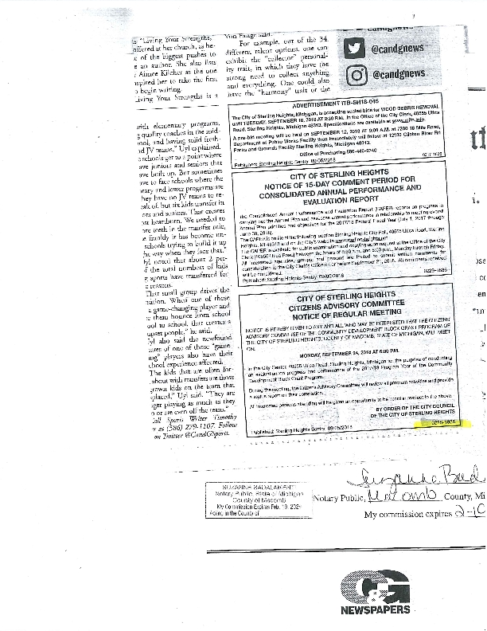
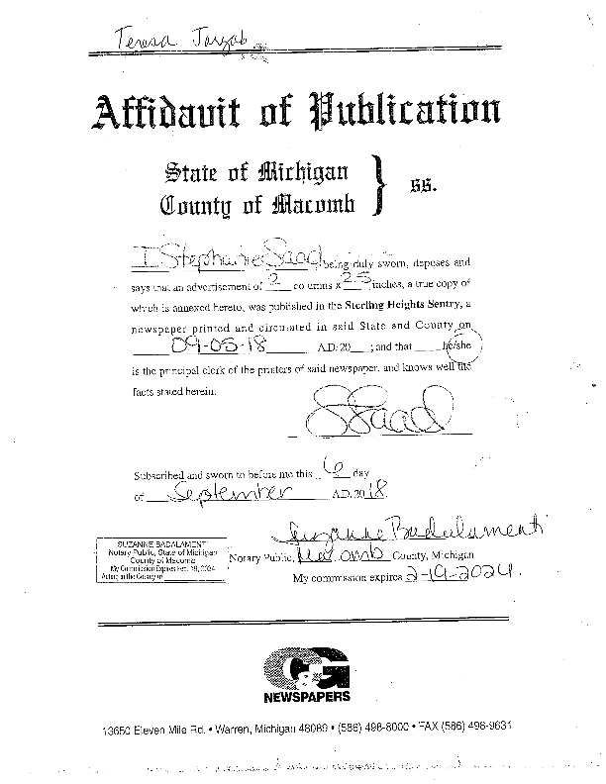

Sec 3 Report
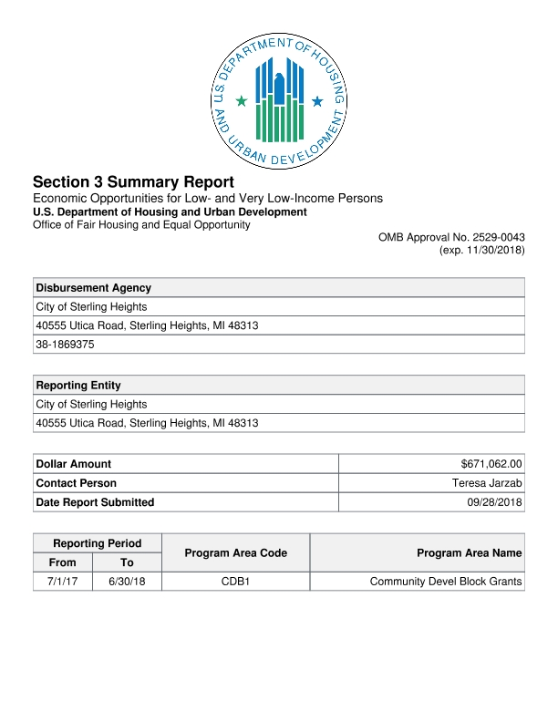
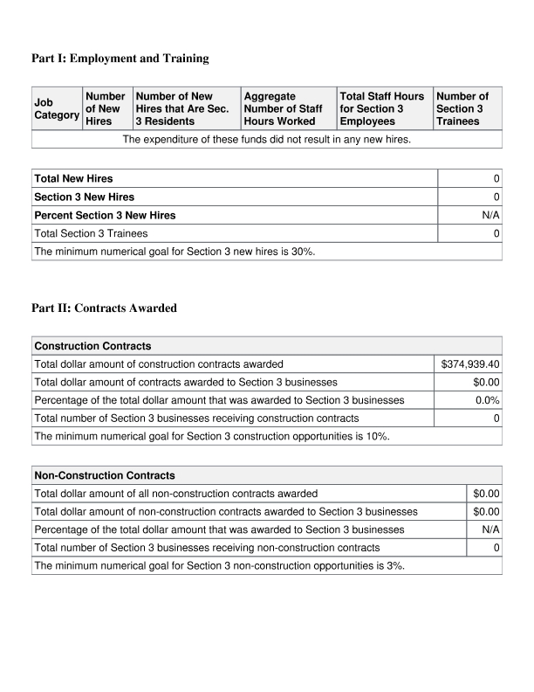
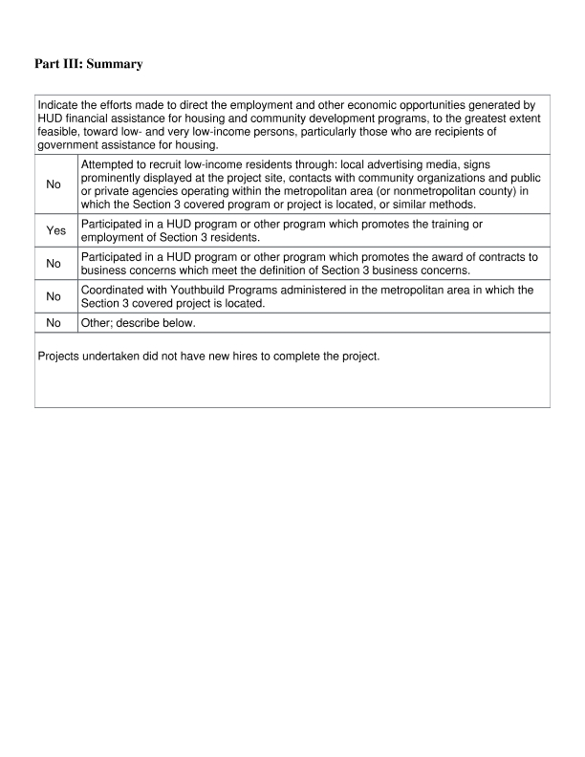

9 24 18 CAC Meeting Minutes
CITY OF STERLING HEIGHTS
CITIZEN ADVISORY COMMITTEE MEETING
MINUTES OF THE REGULAR MEETING
September 24, 2018 – 6:00 P.M.
CITY CENTER – CONFERENCE ROOM #201

Chairperson Janet Bartello called the meeting to order at 6:05 p.m.

Members present at roll call: Eric Castiglia, Joanne Paraventi, Grace Pedrie, Jeanne Schabath, Janet Bartello , Kozeta Elzhenni, Judith Foley

Members absent: None

Also in attendance: Teresa Jarzab, HUD Program Coordinator

Approval of Agenda

Moved by Foley, supported by Paraventi, to approve the agenda as presented.

Ayes: All
Nays: None
Motion Carried.

Approval of Minutes

Moved by Castiglia, supported by Schabath, to approve the minutes of the Regular Meeting of March 26, 2018 as presented.

Ayes: All
Nays: None
Motion Carried.

New Business

Role of the Citizen Advisory Committee- Ms. Bartello open for discussion.

CAPER Report- Ms. Jarzab reviewed the prior program year as reported to HUD

Board members questioned the reprograming of unused funds. Ms. Jarzab stated that according to the Annual Plan, all unused Public Service funds are going into the Home and Property Repair Program (Rehab). Discussion about adding funds to the public services accounts. Ms. Jarzab stated that we can only spend 15% each fiscal year on Public Services and we cannot move funds from prior years to add to current years, as that will take Public Services over the current fiscal year cap.

Moved by Pedrie, supported by Elzehenni, to approve the Regular Meeting Schedule as presented

Ayes: All
Nays: None
Motion Carried.

Old Business

Ms. Jarzab presented the updated 2018-19 Budget line item spreadsheet.

Board Members Report

None

Public Comment

None

Adjournment

Move to adjourn by Pedrie, supported by Elzhenni

Ayes: All
Nays: None
Motion carried.

Meeting adjourned 6:54 p.m.

Respectfully submitted,

Grace Pedrie, Recording Secretary

TJ

