Executive Summary

ES-05 Executive Summary – 24 CFR 91.200(c), 91.220(b)
1. Introduction
The Consolidated Plan identifies the five-year programmatic goals and activities for the Home Investment Partnership Program (HOME) for the Macomb HOME Consortium and the Community Development Block Grant (CDBG). The Macomb HOME Consortium is comprised of the Urban County of Macomb, the Charter Township of Clinton, and the Cities of Roseville and Sterling Heights has prepared this Consolidated Plan (Plan), in order to qualify for CDBG, HOME, and other formula program funding administered by the U.S. Department of Housing & Urban Development (HUD). This Con Plan is effective from July 1, 2019 through June 30, 2024, which includes the 2019-2023 program years.
2. Summary of the objectives and outcomes identified in the Plan Needs Assessment Overview
The Macomb HOME Consortium will provide decent, affordable housing to LMI residents within its jurisdiction, in accordance with the provisions of the National Affordable Housing Act of 1990, as amended. Consortium members will, moreover, use their community development resources in concert with their housing and community development partners, to promote decent housing and a suitable living environment for LMI persons, in accordance with the Housing and Community Development Act of 1949, as amended.
3. Evaluation of past performance
The City has received CDBG funds since 1974. Throughout this time, the city has allocated the funding to many different sources through public and private initiatives. Throughout this history, it has been determined that providing a public and private collaborative environment, the city is able to leverage the financial resources provided through CDBG will other federal, state and local funds which are available in the community to best meet the needs of low and moderate income residents.
Through an assessment of annual project proposals, the city is able to determine how to use these limited funds to best meet the most urgent needs of residents within the city. This program structure has been determined to work well in the past; as such, the city has determined to continue in this manner over the next five years.
Using the same structure, city staff will continue to promote the collaboration of the city and community organizations in order to meet the needs of city residents given the finite amount of resources that are available. Staff will continue to promote the efficient use of CDBG funds through ongoing technical assistance.
4. Summary of citizen participation process and consultation process
During the preparation of this Consolidated Plan, the city provided multiple community participation and input opportunities. These opportunities consisted of two public collaboration sessions during December 2018 and two public hearings in March and May 2019. These opportunities were widely advertised through advertisements in the C & G Newspaper, a newspaper of general circulation in the city; letters and emails sent to a vast number of local nonprofit agencies, and churches.
Lastly, a 30-day public comment period was advertised and held from April 17 through May 17, 2019.
5. Summary of public comments
A summary of the comments received from the focus group and regular meeting minutes, are included as an attachment to this plan.
6. Summary of comments or views not accepted and the reasons for not accepting them
All comments and views submitted in this process were incorporated into the Consolidated Plan.
7. Summary
In sum, the Macomb HOME Consortium has undertaken housing and community development programs for decades. It has repaired homes, helped developmentally-disabled adults find adequate housing and achieve independence, constructed, improved and or expanded public facilities including parks and senior centers, constructed or improved streets, sidewalks and water and sewer facilities, and provided human services to address needs of low-income residents. The 2019-2023 plan will continue, expand, and reinforce these accomplishments.

The Process

PR-05 Lead & Responsible Agencies - 91.200(b)
1. Describe agency/entity responsible for preparing the Consolidated Plan and those responsible for administration of each grant program and funding source
The following are the agencies/entities responsible for preparing the Consolidated Plan and those responsible for administration of each grant program and funding source.
Agency Role | Name | Department/Agency

CDBG Administrator | STERLING HEIGHTS | Neighborhood Services
Table 1– Responsible Agencies

Narrative
Although the Macomb County will be the lead entity responsible for the Consolidated Plan, management of the CDBG programs will be handelled by each entitlement community, and coordinated effort of all organizations working in community development will be needed to implement the plan. The City Planning and Community Development Department, other city departments, neighborhood groups, social service agencies, and other organizations serving low-income residents must work together to effectively improve the community. The City Planning and Community Development Department will also be responsible for providing technical assistance to agencies working on community development activities and monitoring the implementation of projects approved in the 2019 Action Plan, and the subsequent annual action plans.
Consolidated Plan Public Contact Information
Teresa Jarzab, HUD Program Coordinator-Sterling Heights
tjarzab@sterling-heights.net - 586-446-2724

PR-10 Consultation - 91.100, 91.200(b), 91.215(l)
1. Introduction
Sterling Heights, as a member of the Macomb HOME Consortium (MHC), consulted with other government, non-profit, and private agencies to develop the PY 2019-2023 Consolidated Plan. Consultation included public hearings, focus groups, MHC team meetings, surveys, and direct solicitation/outreach.
Provide a concise summary of the jurisdiction’s activities to enhance coordination between public and assisted housing providers and private and governmental health, mental health and service agencies (91.215(I)).
Sterling Heights advertised and held three focus groups during the outreach process for the PY 2019-2023 Consolidated Plan as part of the Macomb HOME Consortium. The focus groups specifically addressed housing needs, public services, public facilities, and infrastructure needs. Public and assisted housing providers, health agencies, mental health agencies, local governments, service organizations and the public were invited to attend. Invitations were sent via email, direct mailing, published in the local newspaper, posted on social media, and by direct phone calls. While the focus groups were well attended, there was a lack of participation by the public housing providers. To encourage their participation, the County sent a survey via email and direct mailing to all six public housing authorities that are located in the jurisdiction of the MHC. The questions contained in the survey were specific to the public housing sections of the Consolidated Plan.
MHC members coordinate with public and private developers and assisted housing providers when they request letters of support for specific projects or Certificates of Consistency with the Con Plan for HUD funding applications. Members may also share information and support public and assisted housing provider projects but due to limited resources, it is not possible to address specific public housing needs with CDBG, HOME and ESG resources. MHC members also participate in the local Continuum of Care (CoC). The CoC works to end homelessness and increase affordable housing opportunities.
Describe coordination with the Continuum of Care and efforts to address the needs of homeless persons (particularly chronically homeless individuals and families, families with children, veterans, and unaccompanied youth) and persons at risk of homelessness
Services for the homeless and those at risk of homelessness was identified as a priority need during the focus groups workshops. The delivery system for these services is strong but is challenged by financial constraints and a great need. The City will continue to work with the local Continuum of Care during the life of the 2019-2023 Consolidated Plan to identify gaps in services that could benefit from CDBG funding.
As reported in the last plan, the system is hindered by varying funding restrictions, which impede cooperation among partners. Each funding source has its own mandates, making it difficult to achieve the inter-organizational alignment necessary to address shared issues. Another constraint boils down to having insufficient money to address all needs. This forces hard choices between high priority needs and objectives, often diminishing opportunities for cooperation.
Describe consultation with the Continuum(s) of Care that serves the jurisdiction's area in determining how to allocate ESG funds, develop performance standards and evaluate outcomes, and develop funding, policies and procedures for the administration of HMIS
Macomb County consults each year with the local Continuum of Care (CoC) to determine how to allocate the County's ESG funds. Program staff also consults with the CoC when developing the performance standards. For evaluating the outcomes of, projects and activities assisted by ESG funds, the County complies with the guidelines established by the CoC's Compliance Committee. As the CoC's lead for HMIS, the Macomb Homeless Coalition establishes policies, and procedures for the administration and operation of the HMIS.
2. Describe Agencies, groups, organizations and others who participated in the process and describe the jurisdictions consultations with housing, social service agencies and other entities

Table 2– Agencies, groups, organizations who participated
1 | Agency/Group/Organization | Macomb Homeless Coalition
1 | Agency/Group/Organization Type | Services-homeless
1 | What section of the Plan was addressed by Consultation? | Homelessness Strategy  Homeless Needs - Chronically homeless  Homeless Needs - Families with children  Homelessness Needs - Veterans  Homelessness Needs - Unaccompanied youth
1 | How was the Agency/Group/Organization consulted and what are the anticipated outcomes of the consultation or areas for improved coordination?
2 | Agency/Group/Organization | Care House
2 | Agency/Group/Organization Type | Services-Children  Services - Victims
2 | What section of the Plan was addressed by Consultation? | Non-Homeless Special Needs
2 | How was the Agency/Group/Organization consulted and what are the anticipated outcomes of the consultation or areas for improved coordination?
3 | Agency/Group/Organization | Interfaith Volunteer Care givers
3 | Agency/Group/Organization Type | Services-Elderly Persons
3 | What section of the Plan was addressed by Consultation? | Non-Homeless Special Needs
3 | How was the Agency/Group/Organization consulted and what are the anticipated outcomes of the consultation or areas for improved coordination?
4 | Agency/Group/Organization | Salvation Army MATTS Shelter
4 | Agency/Group/Organization Type | Services-homeless
4 | What section of the Plan was addressed by Consultation? | Homeless Needs - Chronically homeless  Homeless Needs - Families with children  Homelessness Needs - Veterans
4 | How was the Agency/Group/Organization consulted and what are the anticipated outcomes of the consultation or areas for improved coordination?
5 | Agency/Group/Organization | MACOMB COUNTY COMMUNITY SERVICES AGENCY
5 | Agency/Group/Organization Type | Services-Elderly Persons
5 | What section of the Plan was addressed by Consultation? | Non-Homeless Special Needs
5 | How was the Agency/Group/Organization consulted and what are the anticipated outcomes of the consultation or areas for improved coordination?
6 | Agency/Group/Organization | Macomb Community College
6 | Agency/Group/Organization Type | Services-Education
6 | What section of the Plan was addressed by Consultation? | Economic Development
6 | How was the Agency/Group/Organization consulted and what are the anticipated outcomes of the consultation or areas for improved coordination?
7 | Agency/Group/Organization | MCREST
7 | Agency/Group/Organization Type | Services-homeless
7 | What section of the Plan was addressed by Consultation? | Homeless Needs - Chronically homeless  Homeless Needs - Families with children  Homelessness Needs - Veterans
7 | How was the Agency/Group/Organization consulted and what are the anticipated outcomes of the consultation or areas for improved coordination?
8 | Agency/Group/Organization | STERLING HEIGHTS
8 | Agency/Group/Organization Type | Housing  Services-Elderly Persons  Services-Persons with Disabilities  Other government - Local
8 | What section of the Plan was addressed by Consultation? | Housing Need Assessment  Non-Homeless Special Needs  Market Analysis
8 | How was the Agency/Group/Organization consulted and what are the anticipated outcomes of the consultation or areas for improved coordination? | Minor Home Repair program, for Low Income Seniors and Mobile Home owners.Large Print/Audio books for home bound seniors, and senior housing.Adaptive Recreation for disabled adultsLocal Road improvementsSenior Center improvements
9 | Agency/Group/Organization | Sterling Heights Housing Commission
9 | Agency/Group/Organization Type | PHA  Services-Elderly Persons  Services-Persons with Disabilities
9 | What section of the Plan was addressed by Consultation? | Public Housing Needs
9 | How was the Agency/Group/Organization consulted and what are the anticipated outcomes of the consultation or areas for improved coordination?
10 | Agency/Group/Organization | Turning Point
10 | Agency/Group/Organization Type | Services-Victims of Domestic Violence  Services - Victims
10 | What section of the Plan was addressed by Consultation? | Homeless Needs - Families with children
10 | How was the Agency/Group/Organization consulted and what are the anticipated outcomes of the consultation or areas for improved coordination?
11 | Agency/Group/Organization | Macomb County Warming Center
11 | Agency/Group/Organization Type | Services-homeless
11 | What section of the Plan was addressed by Consultation? | Homeless Needs - Chronically homeless  Homeless Needs - Families with children  Homelessness Needs - Veterans
11 | How was the Agency/Group/Organization consulted and what are the anticipated outcomes of the consultation or areas for improved coordination?
12 | Agency/Group/Organization | Wigs 4 Kids
12 | Agency/Group/Organization Type | Services-Children
12 | What section of the Plan was addressed by Consultation? | Non-Homeless Special Needs
12 | How was the Agency/Group/Organization consulted and what are the anticipated outcomes of the consultation or areas for improved coordination?

Identify any Agency Types not consulted and provide rationale for not consulting
All agencies were given notice for consultation.

Other local/regional/state/federal planning efforts considered when preparing the Plan
Name of Plan | Lead Organization | How do the goals of your Strategic Plan overlap with the goals of each plan?
Continuum of Care | Macomb County Homeless Coalition
Table 3– Other local / regional / federal planning efforts

Describe cooperation and coordination with other public entities, including the State and any adjacent units of general local government, in the implementation of the Consolidated Plan (91.215(l))
The City of Sterling Heights will continue to partner with public entities which work to accomplish community development goals within the city. This includes maintaining coordination with Macomb County and the Michigan State Housing and Development Authority when necessary.

Narrative

PR-15 Citizen Participation - 91.401, 91.105, 91.200(c)
1. Summary of citizen participation process/Efforts made to broaden citizen participation
Summarize citizen participation process and how it impacted goal-setting

The City of Sterling Heights is required to set forth policies and procedures for citizen participation in the process of developing and implementing the Consolidated Plan and all its components. In accordance with federal regulation 24 CFR 91.105, Sterling Heights maintains a Citizen Participation Plan (CPP). The CPP applies to CDBG, and HOME programs as well as to the development and implementation of the Consolidated and Annual Action Plan. The CPP outlines the policies and procedures used by the City to solicit citizen input. The City followed the CPP in the development of the 2019-2023 Consolidated Plan. The CPP requires the City to conduct one public hearing for citizens, and one additional focus group meetings with non-housing, and housing agencies, concerning the Consolidated Plan and other basic program requirements. The City encourages participation in the Consolidated Plan process. The City's 2019-2023 Consolidated Plan citizen participation efforts included the following efforts to achieve maximum feasible public participation Advertised citizen participation opportunities in local newspaper, and online. Encouraged participation by holding events at accessible locations. Mailed survey and workshop flyers to members of the local Continuum of Care and Public Housing Authorities through the Macomb HOME Consortium. Distributed surveys to expand public participation through the Macomb HOME Consortium. The City considers comments from citizens, service organizations and internal departments, received in writing or verbally at public hearings in preparing the final Consolidated Plan. The plan is then made available for 30 days for additional public comment before final approval by the City Council.

Citizen Participation Outreach
Sort Order | Mode of Outreach | Target of Outreach | Summary of  response/attendance | Summary of  comments received | Summary of comments not accepted and reasons | URL (If applicable)
1 | Public Meeting | Non-targeted/broad community | December 3, 2018 Sterling Heights held a public hearing to receive input on the 2019/2020 Annual Action Plan. the meeting was attended by Community Organizations, Parks & Recreation, Library, Engineering Staff, and residents. | Attendees provided comments on the importance of education, homeless needs, public services, and infrastructure improvements.
2 | Public Meeting | Non-targeted/broad community | February 6, 2019 Sterling Heights held a public meeting and workshop to receive input on the 2019 5 Year Consolidated Plan. The meeting was attended by City Officials, and community organizations | Attendees provided comments on the importance of public services, infrastructure and code enforcement
3 | Newspaper Ad | Non-targeted/broad community | Sterling Heights published in the local newspapers Notice of Public Hearings for the December 2018 Meeting as well as the March 2019 public meeting. | No comments were received.
4 | Public Meeting | Non-targeted/broad community | the Citizen Advisory Committee held a meeting March 11, 2019 to make recommendations to the City Council on the anticipated 2019 funding. | Attendees provided comments on the importance of education, homeless needs, public services, and infrastructure improvements.
Table 4– Citizen Participation Outreach

Needs Assessment

NA-05 Overview
Needs Assessment Overview
HUD grantees are required to submit their Consolidated Plan (Con Plan) and year one Annual Action Plan using the template provided by HUD’S Integrated Disbursement Information System (IDIS) eCon Planning Suite. The template provides the grantee with pre-populated tables and graphs which are used to determine housing needs.
The primary data sources used by HUD to pre-populate the IDIS template for the Macomb HOME Consortium’s 2019-2023 Con Plan is the 2009-2013 American Community Survey (ACS) and the 2011-2015 Comprehensive Housing Affordability Strategy (CHAS).
The ACS is an ongoing survey that provides vital information on a yearly basis about the nation and its people. Information from the survey generates data that help determine how federal and state funds are distributed each year. The CHAS data is a custom tabulation of the ACS data. The CHAS data demonstrates housing problems and housing needs, particularly for low-income households.
Other data sources used to complete the Housing Needs Assessment for the Macomb HOME Consortium’s 2019-2023 Consolidated Plan includes:
- U.S. Department of Housing and Urban Development
- Southeast Michigan Council of Governments
- Macomb County Department of Planning and Economic Development
- Macomb County Continuum of Care - Macomb Homeless Coalition
- Macomb Community Action - Community Needs Assessment
Sterling Heights has experienced significant changes in its housing market, employment and social characteristics since the last Con Plan was completed in 2014. The following assessment analyzes need on a variety of factors including income. Federal program regulations related CDBG, and HOME funding requires the grantee to report the income levels of those served. Income limits are based on HUD estimates of median household income for an area, adjusted for family size.

NA-50 Non-Housing Community Development Needs - 91.415, 91.215 (f)
Describe the jurisdiction’s need for Public Facilities:
There are many public facilities throughout the City of Sterling Heights, which exist to meet the needs of all populations, including low and moderate-income individuals and families. Additionally, there are many community-based organizations, which own and operate facilities, which also work to meet the needs of residents with special needs, homeless individuals and families, persons with disabilities and low and moderate-income individuals and families. Continued improvements and upgrading of existing facilities to continue to provide the space needed to meet the needs of residents with low and moderate-income individuals and families is one of the greatest needs existing within the city.

How were these needs determined?
Through consultations with community-based public and private, nonprofit organizations, through review of the community needs assessment, and through the public comments which were received during applications for funding these needs were identified.

Describe the jurisdiction’s need for Public Improvements:
The need for public improvements targeted through the use of CDBG funds is very similar to the needs expressed for public facilities. The existing facilities which currently meet the needs of the public are continually in need of reinvestment in order to maintain sustainability of these facilities. Through targeting the use of CDBG funds to improve existing facilities, which directly serve low and moderate income residents, the city is able to best meet this need.

How were these needs determined?
Through consultations with community-based public and private, nonprofit organizations, through review of the community needs assessment, and through the public comments, which were received during applications for funding these needs, were identified.

Describe the jurisdiction’s need for Public Services:
The City of Sterling Heights has identified that providing services which offer assistance to low-income residents who are in need of housing, and other support is needed. Through collaborating with locally operating community-based organizations, these services can be best provided by the individuals who specialize in these areas. Within the first year of the plan, the city has identified the need to provide support to persons needing housing services, and those families who are at-risk and in need of additional support provide through various public service providers. On an annual basis, the city will review the proposed funding applications for the year, which propose the best ways in which to provide support services to low-income residents, including work, housing and transportation services.

How were these needs determined?
Through consultations with community-based public and private, nonprofit organizations, through review of the community needs assessment, and through the public comments, which were received during applications for funding these needs, were identified.

Based on the needs analysis above, describe the State's needs in Colonias

Housing Market Analysis

MA-05 Overview
Housing Market Analysis Overview:
The Housing Market Analysis section of this plan is intended to provide a clear picture of the local housing market, public and assisted housing needs, homeless and special need facilities, barriers to affordable housing and characteristics of the local economy and workforce.

Key points of the Housing Market Analysis include:
General Characteristics – through consultation with housing service agencies operating in the city and review of the available data through the U.S. Census Bureau, the City Building Department and other credible sources, this analysis describes the significant characteristics of the housing market in terms of supply, demand, condition, and the cost of housing.
Public Housing – This portion of the analysis briefly describes the local governmentally owned senior housing units, owned and operated by the City of Sterling Heights.
Homeless Inventory – a brief inventory is given of existing facilities, housing and services that meet the needs of homeless persons within the city. Additionally, an inventory of services is included, which target homeless persons and mainstream services.

MA-45 Non-Housing Community Development Assets - 91.410, 91.210(f)
Introduction
The following is a summary of the economic activity within Sterling Heights. The data was provided by the U. S. Census Bureau 2009-2013 American Communities Survey.
Economic Development Market Analysis
Business Activity
Business by Sector | Number of Workers | Number of Jobs | Share of Workers  % | Share of Jobs  % | Jobs less workers  %
Agriculture, Mining, Oil & Gas Extraction | 102 | 50 | 0 | 0 | 0
Arts, Entertainment, Accommodations | 5,521 | 5,050 | 11 | 11 | 0
Construction | 1,608 | 2,759 | 3 | 6 | 3
Education and Health Care Services | 9,406 | 5,344 | 19 | 12 | -7
Finance, Insurance, and Real Estate | 3,078 | 2,221 | 6 | 5 | -1
Information | 976 | 489 | 2 | 1 | -1
Manufacturing | 7,966 | 12,804 | 16 | 28 | 12
Other Services | 1,898 | 1,372 | 4 | 3 | -1
Professional, Scientific, Management Services | 7,013 | 4,875 | 14 | 11 | -3
Public Administration | 0 | 0 | 0 | 0 | 0
Retail Trade | 7,969 | 6,982 | 16 | 15 | -1
Transportation and Warehousing | 1,230 | 641 | 2 | 1 | -1
Wholesale Trade | 2,807 | 2,868 | 6 | 6 | 0
Total | 49,574 | 45,455 | -- | -- | --
Table 5 - Business Activity
Data Source: | 2009-2013 ACS (Workers), 2013 Longitudinal Employer-Household Dynamics (Jobs)

Labor Force
Total Population in the Civilian Labor Force | 67,306
Civilian Employed Population 16 years and over | 59,289
Unemployment Rate | 11.91
Unemployment Rate for Ages 16-24 | 28.29
Unemployment Rate for Ages 25-65 | 8.04
Table 6 - Labor Force
Data Source: | 2009-2013 ACS

Occupations by Sector | Number of People
Management, business and financial | 14,132
Farming, fisheries and forestry occupations | 2,547
Service | 6,795
Sales and office | 15,660
Construction, extraction, maintenance and repair | 3,709
Production, transportation and material moving | 3,605
Table 7 – Occupations by Sector
Data Source: | 2009-2013 ACS

Travel Time
Travel Time | Number | Percentage
< 30 Minutes | 34,483 | 61%
30-59 Minutes | 19,295 | 34%
60 or More Minutes | 2,886 | 5%
Total | 56,664 | 100%
Table 8 - Travel Time
Data Source: | 2009-2013 ACS

Education:
Educational Attainment by Employment Status (Population 16 and Older)
Educational Attainment | In Labor Force
Educational Attainment | Civilian Employed | Unemployed | Not in Labor Force
Less than high school graduate | 3,806 | 1,063 | 3,101
High school graduate (includes equivalency) | 12,001 | 1,794 | 5,020
Some college or Associate's degree | 17,304 | 1,733 | 4,401
Bachelor's degree or higher | 16,573 | 1,111 | 2,946
Table 9 - Educational Attainment by Employment Status
Data Source: | 2009-2013 ACS

Educational Attainment by Age
 | Age
 | 18–24 yrs | 25–34 yrs | 35–44 yrs | 45–65 yrs | 65+ yrs
Less than 9th grade | 349 | 440 | 621 | 2,282 | 2,870
9th to 12th grade, no diploma | 1,277 | 1,338 | 1,366 | 1,923 | 2,142
High school graduate, GED, or alternative | 2,499 | 3,882 | 4,325 | 10,608 | 7,641
Some college, no degree | 4,935 | 3,594 | 4,314 | 8,561 | 3,674
Associate's degree | 644 | 1,654 | 1,646 | 3,729 | 1,263
Bachelor's degree | 1,304 | 3,731 | 3,369 | 6,219 | 1,917
Graduate or professional degree | 76 | 2,055 | 1,903 | 3,360 | 1,093
Table 10 - Educational Attainment by Age
Data Source: | 2009-2013 ACS

Educational Attainment – Median Earnings in the Past 12 Months
Educational Attainment | Median Earnings in the Past 12 Months
Less than high school graduate | 18,435
High school graduate (includes equivalency) | 27,227
Some college or Associate's degree | 37,851
Bachelor's degree | 50,848
Graduate or professional degree | 67,058
Table 11 – Median Earnings in the Past 12 Months
Data Source: | 2009-2013 ACS

Based on the Business Activity table above, what are the major employment sectors within your jurisdiction?
The top three largest employment sectors in Sterling Heights are manufacturing, retail trade, and education and health care service sector. Additionally, the construction sector shows strength in that the number of jobs (2,759) exceeds the number of workers (1,608). The Manufacturing sector also shows that the number of jobs (12,804) exceeds the number of workers (7,966).
There is also a noteworthy number of jobs and workers in the arts, entertainment & accommodations with 5,050 jobs and professional, scientific, management services 4,875 jobs.

Describe the workforce and infrastructure needs of the business community:
The top three occupations in Sterling Heights are 1) sales and office, with 34% 2) management, business, and financial with 30%, and 3) service, with 15%.
61% of workers in Sterling Heights have a less than 30 minute commute time; and, 34% of workers in Sterling Heights have a 30 to 59 minute commute time.

Describe any major changes that may have an economic impact, such as planned local or regional public or private sector investments or initiatives that have affected or may affect job and business growth opportunities during the planning period. Describe any needs for workforce development, business support or infrastructure these changes may create.
The City over the course of the last five years has seen significant growth and investment, which has led to significant job opportunities. The City has seen a major windfall of industrial development from tier suppliers to the major automobile companies. This is largely related to the billion dollars plus re-investment by FCA into the Sterling Heights Assembly Plant to build the Dodge Ram pickup. As a result, for instance, in the year 2018, the City saw building permits for the development or redevelopment of 1.3 million square feet of commercial and industrial properties. New industrial buildings including Mitchell Plastics, Metulsa, Mor-Tech, U-Tech, HTI Cybernetics, among others have built and expanded businesses in the City totaling approximately 700,000 square feet and have directly generated hundreds of new jobs and likely hundreds of other spin off jobs for local restaurants, retail providers, etc. This includes new headquarters building for Christian Financial Credit Union with over 100 jobs, with five (5) new hotels in the planning and engineering phases and set to break ground soon, and tens of thousands of new retail and office space.
The next five years, the City anticipates continued investment in the industrial and retail sector, with current industrial businesses looking for expansion opportunities and several new major industrial buildings being planned, continuing the increase in living and working opportunities in the City. The City currently has approximately 2,000 homes in the planning, engineering or construction phases. These range from low/mod income apartment units to high-end single-family homes. Part of this total number of homes is the planned investment in the City’s North River, of a new mixed-use development that will include retail first floor tenants and low to moderate income housing on the upper stories. The City hopes this major; multiple million-dollar investment will be the genesis for other new similar type developments in this area of the City. Finally, the City has been planning for the evolution of the current Lakeside Mall. The Mall has traditionally been one of the largest employers within the City. Based on current retail trends and economic conditions it appears the Mall will need to evolve and the evolution will likely include additional housing opportunities, new retail uses and likely new medical/office uses which are not currently located in that area; all of which will bring a new economic infusion to the City as a whole.
In 2019, total road improvements in Sterling Heights over $23.3 Million are slated for upgrading and reconstructing roads. Roads are a critical element of the economic development and infrastructure in our city. Roads need to be maintained and repaired in order to provide the safe, efficient, reliable and quick transportation for both goods and services.
Sterling Heights draws from a regional, diverse and highly skilled workforce. With the growth in the manufacturing sector as noted above, shows a need for almost 50% more skilled workers than we currently have.
How do the skills and education of the current workforce correspond to employment opportunities in the jurisdiction?
The unemployment rate is much higher in the 16-year to 24-year age bracket, at 28.29%. Comparatively, the unemployment rate for people age 25 to 65 is 8.04%. Combining to an overall unemployment rate of 11.91%.
Educational attainment in Sterling Heights appears to be correlated to employment rates. For instance, for persons with a bachelor’s degree or higher, less than 1% are un-employed, employment with college degrees, about 1% are unemployed and about 40% are not in the labor force. On the other extreme persons with less than high school diploma, about 49 are employed, about 3% are unemployed and 48% are not in the labor market. People age 25 to 65 accounts for the vast majority of college-educated people, representing approximately 90% of those with an associate degree, those with a bachelor’s degree, and those with a graduate or professional degree. These two factors considered together, educational attainment by employment status and educational attainment by age combine to suggest and inform the high unemployment rates seen by persons age 16 to 24. Data supports a hypothesis that the high unemployment rate in this age group correlates to this cohort not having had time yet to achieve education and specialization commensurate with higher rates of employment.
Describe any current workforce training initiatives, including those supported by Workforce Investment Boards, community colleges and other organizations. Describe how these efforts will support the jurisdiction's Consolidated Plan.
Macomb County subsidiaries of Michigan Works! are actively involved in workforce training, development activities and other economic development opportunities in the County. Some of these initiatives are targeted specifically in the areas low-income and minority residents reside.
During the last plan funding cycle Sterling Heights supported programs for workforce development at the community college.
The Consortium anticipates similar opportunities to be coordinated in the 2019 to 2023 planning cycle in support of the plan's objective to “Foster Economic Development.”

Does your jurisdiction participate in a Comprehensive Economic Development Strategy (CEDS)?
No
If so, what economic development initiatives are you undertaking that may be coordinated with the Consolidated Plan? If not, describe other local/regional plans or initiatives that impact economic growth.
No
Discussion

MA-50 Needs and Market Analysis Discussion
Are there areas where households with multiple housing problems are concentrated? (include a definition of "concentration")
Reviewing CHAS data through the HUD CPD mapping tool does not reveal discernable patterns showing concentrations of multiple housing problems. Problems appear to be random across census tracts; however, it is fair to say that problems are generally more concentrated in the southern and eastern, more urbanized areas of the County including Mount Clemens, Clinton Township, Eastpointe, Roseville, New Haven, and Sterling Heights. Because the patterns are inconsistent, it is not possible to specifically define a concentration. The County considers a "concentration" to be an area that is 20 points higher and the jurisdiction as a whole.

As discussed at length in the needs analysis section of this plan, cost burden is highest prevalence of housing problems experienced. This needs analysis also notes some income levels where housing problems are disproportional, or greater than 10 percent more, than the jurisdiction as a whole are experienced across racial and ethnic classifications. The following bullets restate and summarize the findings presented in the needs analysis.

HUD recognizes a disproportionally greater need when one racial group experiences greater than 10% points more of a particular housing issue than the jurisdiction as a whole. The data provided in sections NA-20 and NA-25 reflected some instances of disproportionate need. However, the data did not reflect a consistent pattern. The following bullets summarize where proportions of one race exceeded the jurisdiction as a whole by more than 10%.

Are there any areas in the jurisdiction where racial or ethnic minorities or low-income families are concentrated? (include a definition of "concentration")
One definition provided by HUD describes a Minority Neighborhood as a "neighborhood in which the percentage of persons of a particular racial or ethnic minority is at least 20 points higher than that minority's percentage in the housing market as a whole; the neighborhood's total percentage of minority persons is at least 20 points higher than the total percentage of minorities for the housing market area as a whole; or in the case of a metropolitan area, the neighborhood's total percentage of minority persons exceeds 50 percent of its population".
Based on the CHAS data provided by the HUD CPD mapping tool, there are census tract block groups that reflect areas of minority concentration in Eastpointe, Mount Clemens, and Clinton Township. Black or African Americans make up 12 percent of the population in Macomb County. However, there are multiple census tract block groups in Eastpointe, Mount Clemens, and Clinton Township where Black or African Americans exceeds 32 percent of the population. There are also areas of concentration in Sterling Heights where the Asian population exceeds 20 percent of the County as a whole.

What are the characteristics of the market in these areas/neighborhoods?
Generally, a review of CHAS data through the HUD CPD mapping tool, reveals that the more urbanized areas referenced have higher percentages of renters and older housing stock.

Are there any community assets in these areas/neighborhoods?
No specific community assets were discussed during the plan outreach and analysis beyond countywide or census tract comparisons were not conducted in preparation of this plan. The Consortium received feedback that parks, senior centers, and community centers are valuable resources to low-income residents and neighborhoods. Areas that had these facilities are in need of maintenance, services and staffing, areas without these facilities will be considered for projects in the next planning cycle; although resources are limited.
The transportation system, roads, crossing, sidewalks, bikeways/paths, and transit system is another asset that was discussed at length in the preparation of this plan. The Consortium recognizes a need to support the preservation and expansion of transportation that serves low-income areas and neighborhoods.
Finally, public service providers are a great asset to low-income areas and neighborhoods. As stated in previous sections of the plan the Consortium will continue to work with these organizations to deliver high quality housing and public service programming to low-income residents.

Are there other strategic opportunities in any of these areas?
The strategies align with the strategies previously outlined for public and assisted housing with a few additions and modifications including:
- Housing: Continuing to provide housing assistance, and when possible expand affordable housing options by supporting efforts to increase funding to address the huge demand.
- Target Incentives: Prioritize programs that focus on specific populations in need, especially populations that may be underserved.
- Upward Mobility: Provide residents with supportive services to enable them to achieve independence and financial security.
- Invest in Public Facilities and Improvements: Provide safe recreational facilities for low-income families so that residents and their children can have a safe place to play.
- Invest in Transportation: Build and maintain equitable transportation systems and services that provide for the basic living needs of low-income residents and neighborhoods.

Strategic Plan

SP-05 Overview
Strategic Plan Overview
Sterling Heights is expected to receive an average of $780,000 in Community Development Block Grant (CDBG), over the next five years. Macomb County will work with the community to fund eligible projects and services. The Macomb HOME Consortium is expected to receive an average of $1.6 million each year through the HOME Investment Partnerships Program (HOME). As a member, Sterling Heights is expected to receive $300,000 in HOME funds, and is responsible for administering the HOME funds in compliance with the Macomb HOME Consortium's Interlocal Agreement.

The City and members of the Macomb HOME Consortium will work with local units of government, housing agencies and public service providers to remove barriers to affordable housing assist the homeless population, reduce the number of families experiencing poverty and other efforts identified in this strategic plan. Activities not included as a priority need may be allowed based on public input and compliance with a National Objective and the goals outlined in this Plan.

Plan
Through these efforts, the City has identified the following goals to address priority need:
1) Improve Public Facilities and Infrastructure;
2) Make Available Appropriate Housing;
3) Address the Needs of Homeless & At-Risk Families;
4) Provide and Expand Human Services;
5) Expand Comprehensive Planning, Management and Capacity; and
6) Foster Economic Development.
The Strategic Plan provides an overview of why Sterling Heights and the Macomb HOME Consortium may invest CDBG, and HOME, funds over the five year period covered under this Plan. These federal funds will be used to address the following priority needs in the community.
- Housing Rehabilitation
- New Affordable Housing Units
- Rental Housing (including PHA)
- Down-payment Assistance
- Accessibility/Barrier Free Improvements
- Energy Efficiency Improvements
- Property Acquisition/Rehabilitation/Resale (homebuyer)
- Code Enforcement
- Parks, Recreation and Community Facilities
- Street, Sidewalk, Water/Sewer Improvements
- Other Public Facilities and Improvements
- Tree Planting
- Demolition, Clearance and Remediation
- Local and Regional Planning/General Program Administration
- Transportation Services
- Senior and Youth Facilities and Services
- Permanent Supportive Housing
- Emergency Shelters/Transitional Housing
- Supportive Services
- Fair Housing
- Food Bank Services
- Economic Development
- Historic Preservation
- Urgent Need

SP-10 Geographic Priorities - 91.415, 91.215(a)(1)
Geographic Area
Table 12 - Geographic Priority Areas
1 | Area Name: | Low Mod Census Tracks
1 | Area Type: | Local Target area
1 | Other Target Area Description:
1 | HUD Approval Date:
1 | % of Low/ Mod:
1 | Revital Type: | Other
1 | Other Revital Description: | Census Tracks
1 | Identify the neighborhood boundaries for this target area.
1 | Include specific housing and commercial characteristics of this target area.
1 | How did your consultation and citizen participation process help you to identify this neighborhood as a target area?
1 | Identify the needs in this target area.
1 | What are the opportunities for improvement in this target area?
1 | Are there barriers to improvement in this target area?
2 | Area Name: | Low Mod Residents
2 | Area Type: | Local Target area
2 | Other Target Area Description:
2 | HUD Approval Date:
2 | % of Low/ Mod:
2 | Revital Type: | Other
2 | Other Revital Description: | Low Mod Residents
2 | Identify the neighborhood boundaries for this target area.
2 | Include specific housing and commercial characteristics of this target area.
2 | How did your consultation and citizen participation process help you to identify this neighborhood as a target area?
2 | Identify the needs in this target area.
2 | What are the opportunities for improvement in this target area?
2 | Are there barriers to improvement in this target area?

General Allocation Priorities
Describe the basis for allocating investments geographically within the state

SP-25 Priority Needs - 91.415, 91.215(a)(2)
Priority Needs
Table 13 – Priority Needs Summary
1 | Priority Need Name | Rental Housing
1 | Priority Level | High
1 | Population | Extremely Low  Low  Moderate  Middle  Large Families  Families with Children  Elderly  Public Housing Residents  Chronic Homelessness  Individuals  Families with Children  Mentally Ill  Chronic Substance Abuse  veterans  Persons with HIV/AIDS  Victims of Domestic Violence  Elderly  Frail Elderly  Persons with Mental Disabilities  Persons with Physical Disabilities  Persons with Developmental Disabilities  Persons with Alcohol or Other Addictions  Persons with HIV/AIDS and their Families  Victims of Domestic Violence
1 | Geographic Areas Affected | Low Mod Residents
1 | Associated Goals | Make Available Appropriate Housing  Address the Needs of Homeless & At-Risk Families
1 | Description | Provide adequate rental housing for low income persons and families.
1 | Basis for Relative Priority | Need based on public input and housing needs assessment.
2 | Priority Need Name | Housing Rehabilitation
2 | Priority Level | High
2 | Population | Extremely Low  Low  Moderate  Large Families  Families with Children  Elderly  Elderly  Frail Elderly  Persons with Physical Disabilities
2 | Geographic Areas Affected | Low Mod Residents
2 | Associated Goals | Make Available Appropriate Housing
2 | Description | Provide assistance to low-mod homeowners to complete necessary repairs
2 | Basis for Relative Priority | Need based on community and public input.
3 | Priority Need Name | Affodable Housing Units
3 | Priority Level | High
3 | Population | Extremely Low  Low  Moderate  Large Families  Families with Children  Elderly  Public Housing Residents  Elderly  Victims of Domestic Violence
3 | Geographic Areas Affected | Low Mod Residents
3 | Associated Goals | Make Available Appropriate Housing
3 | Description | Provide assistance to low-mod homeowners to complete necessary repairs
3 | Basis for Relative Priority | Need based on community and public input.
4 | Priority Need Name | Public Improvements
4 | Priority Level | High
4 | Population | Extremely Low  Low  Moderate  Large Families  Families with Children  Elderly  Public Housing Residents  Persons with Physical Disabilities  Persons with Developmental Disabilities  Non-housing Community Development
4 | Geographic Areas Affected | Low Mod Census Tracks  Low Mod Residents
4 | Associated Goals | Improve Public Facilities and Infrastructure
4 | Description | Develop public facilities to improve quality of life for low income residents and in low income neighborhoods
4 | Basis for Relative Priority | Need based on community and public input.
5 | Priority Need Name | Public Facilities
5 | Priority Level | High
5 | Population | Extremely Low  Low  Moderate  Large Families  Families with Children  Elderly  Public Housing Residents  Non-housing Community Development
5 | Geographic Areas Affected | Low Mod Census Tracks  Low Mod Residents
5 | Associated Goals | Improve Public Facilities and Infrastructure
5 | Description | Address infrastructure needs for low income residents and in low income neighborhoods.
5 | Basis for Relative Priority | Need based on community and public input.
6 | Priority Need Name | Permanent Supportive Housing
6 | Priority Level | High
6 | Population | Extremely Low  Low  Large Families  Families with Children  Elderly  Rural  Chronic Homelessness  Individuals  Families with Children  Mentally Ill  Chronic Substance Abuse  veterans  Persons with HIV/AIDS  Victims of Domestic Violence  Unaccompanied Youth  Elderly  Persons with Mental Disabilities  Persons with Physical Disabilities  Persons with Developmental Disabilities  Persons with Alcohol or Other Addictions  Persons with HIV/AIDS and their Families  Victims of Domestic Violence
6 | Geographic Areas Affected | Low Mod Residents
6 | Associated Goals | Make Available Appropriate Housing  Address the Needs of Homeless & At-Risk Families
6 | Description | Support Homeless prevention and rapid re-housing.
6 | Basis for Relative Priority | Need based on community and public input.
7 | Priority Need Name | Emergency Shelters and Transitional Housing
7 | Priority Level | High
7 | Population | Extremely Low  Low  Large Families  Families with Children  Elderly  Rural  Chronic Homelessness  Individuals  Families with Children  Mentally Ill  Chronic Substance Abuse  veterans  Persons with HIV/AIDS  Victims of Domestic Violence  Unaccompanied Youth
7 | Geographic Areas Affected | Low Mod Residents
7 | Associated Goals | Make Available Appropriate Housing  Address the Needs of Homeless & At-Risk Families
7 | Description | Provide housing and shelter opportunity to populations in need.
7 | Basis for Relative Priority | Need based on community and public input.
8 | Priority Need Name | Transportation Services
8 | Priority Level | High
8 | Population | Extremely Low  Low  Moderate  Large Families  Families with Children  Elderly  Public Housing Residents  Elderly  Frail Elderly  Persons with Mental Disabilities  Persons with Physical Disabilities  Persons with Developmental Disabilities  Persons with Alcohol or Other Addictions  Persons with HIV/AIDS and their Families  Victims of Domestic Violence
8 | Geographic Areas Affected | Low Mod Census Tracks  Low Mod Residents
8 | Associated Goals | Provide and Expand Human Services
8 | Description | Improve transportation for low-income residents
8 | Basis for Relative Priority | Need based on community and public input.
9 | Priority Need Name | Senior and Youth Facilities and Services
9 | Priority Level | High
9 | Population | Extremely Low  Low  Moderate  Large Families  Families with Children  Elderly  Public Housing Residents  Elderly  Frail Elderly  Non-housing Community Development
9 | Geographic Areas Affected | Low Mod Residents
9 | Associated Goals | Make Available Appropriate Housing  Improve Public Facilities and Infrastructure  Provide and Expand Human Services
9 | Description | Continue and improve programs and facilities that serve seniors and eligible youth.
9 | Basis for Relative Priority | Need based on community and public input.
10 | Priority Need Name | Public Services
10 | Priority Level | High
10 | Population | Extremely Low  Low  Moderate  Large Families  Families with Children  Elderly  Public Housing Residents  Chronic Homelessness  Individuals  Families with Children  Mentally Ill  Chronic Substance Abuse  veterans  Persons with HIV/AIDS  Victims of Domestic Violence  Unaccompanied Youth  Elderly  Frail Elderly  Persons with Mental Disabilities  Persons with Physical Disabilities  Persons with Developmental Disabilities  Persons with Alcohol or Other Addictions  Persons with HIV/AIDS and their Families  Victims of Domestic Violence  Non-housing Community Development
10 | Geographic Areas Affected | Low Mod Residents
10 | Associated Goals | Make Available Appropriate Housing  Improve Public Facilities and Infrastructure  Provide and Expand Human Services  Foster Economic Development  Aid the Prevention of Slums and Blight  Expand Planning, Grant Management and Capacity  Address the Needs of Homeless & At-Risk Families
10 | Description | Provide services and access to public resources for low income residents.
10 | Basis for Relative Priority | Need based on community and public input.
11 | Priority Need Name | Accessibility/Barrier Free Improvements
11 | Priority Level | Low
11 | Population | Extremely Low  Low  Moderate  Large Families  Families with Children  Elderly  Elderly  Persons with Physical Disabilities  Persons with Developmental Disabilities
11 | Geographic Areas Affected | Low Mod Residents
11 | Associated Goals | Make Available Appropriate Housing  Improve Public Facilities and Infrastructure
11 | Description | Improve accessibility for low-income residents
11 | Basis for Relative Priority | Need based on community and public input.
12 | Priority Need Name | Code Enforecement & Crime Prevention
12 | Priority Level | Low
12 | Population | Extremely Low  Low  Moderate  Large Families  Families with Children  Elderly  Public Housing Residents
12 | Geographic Areas Affected | Low Mod Census Tracks
12 | Associated Goals | Make Available Appropriate Housing  Provide and Expand Human Services  Foster Economic Development  Aid the Prevention of Slums and Blight
12 | Description | Improve and continue code enforcement activities in low income neighborhoods.
12 | Basis for Relative Priority | Need based on community and public input.
13 | Priority Need Name | Fair Housing
13 | Priority Level | Low
13 | Population | Extremely Low  Low  Moderate  Large Families  Families with Children  Elderly  Public Housing Residents  Rural  Chronic Homelessness  Individuals  Families with Children  Mentally Ill  Chronic Substance Abuse  veterans  Persons with HIV/AIDS  Victims of Domestic Violence  Unaccompanied Youth  Elderly  Frail Elderly  Persons with Mental Disabilities  Persons with Physical Disabilities  Persons with Developmental Disabilities  Persons with Alcohol or Other Addictions  Persons with HIV/AIDS and their Families  Victims of Domestic Violence
13 | Geographic Areas Affected | Low Mod Residents
13 | Associated Goals | Make Available Appropriate Housing  Provide and Expand Human Services  Expand Planning, Grant Management and Capacity  Address the Needs of Homeless & At-Risk Families
13 | Description | Promote access to housing for all residents that qualify.
13 | Basis for Relative Priority | Need based on community and public input.
14 | Priority Need Name | Food Bank Services
14 | Priority Level | Low
14 | Population | Extremely Low  Low  Moderate  Large Families  Families with Children  Elderly  Public Housing Residents  Rural  Chronic Homelessness  Individuals  Families with Children  Mentally Ill  Chronic Substance Abuse  veterans  Persons with HIV/AIDS  Victims of Domestic Violence  Unaccompanied Youth  Elderly  Frail Elderly  Persons with Mental Disabilities  Persons with Physical Disabilities  Persons with Developmental Disabilities  Persons with Alcohol or Other Addictions  Persons with HIV/AIDS and their Families  Victims of Domestic Violence
14 | Geographic Areas Affected | Low Mod Residents
14 | Associated Goals | Provide and Expand Human Services
14 | Description | Provide food access services and programs to support low income residents.
14 | Basis for Relative Priority | Need based on community and public input.
15 | Priority Need Name | Local and Regional Planning
15 | Priority Level | Low
15 | Population | Extremely Low  Low  Moderate  Large Families  Families with Children  Elderly  Public Housing Residents  Rural  Chronic Homelessness  Individuals  Families with Children  Mentally Ill  Chronic Substance Abuse  veterans  Persons with HIV/AIDS  Victims of Domestic Violence  Unaccompanied Youth  Elderly  Frail Elderly  Persons with Mental Disabilities  Persons with Physical Disabilities  Persons with Developmental Disabilities  Persons with Alcohol or Other Addictions  Persons with HIV/AIDS and their Families  Victims of Domestic Violence  Non-housing Community Development
15 | Geographic Areas Affected | Low Mod Census Tracks  Low Mod Residents
15 | Associated Goals | Expand Planning, Grant Management and Capacity
15 | Description | Improve planning for regional coordination of housing and community development activities.
15 | Basis for Relative Priority | Need based on community and public input.
16 | Priority Need Name | Demolition, Clearance, & Remediation
16 | Priority Level | Low
16 | Population | Extremely Low  Low  Moderate  Large Families  Families with Children  Elderly  Public Housing Residents
16 | Geographic Areas Affected | Low Mod Census Tracks
16 | Associated Goals | Foster Economic Development  Aid the Prevention of Slums and Blight
16 | Description | Demo blighted properties.
16 | Basis for Relative Priority | Need based on community and public input.
17 | Priority Need Name | Energy Efficiency Improvements
17 | Priority Level | Low
17 | Population | Extremely Low  Low  Moderate  Large Families  Families with Children  Elderly  Elderly  Frail Elderly
17 | Geographic Areas Affected | Low Mod Residents
17 | Associated Goals | Make Available Appropriate Housing
17 | Description | Create opportunities for energy efficiency improvements that improve low income resident housing.
17 | Basis for Relative Priority | Need based on community and public input.
18 | Priority Need Name | Down Payment Assistance
18 | Priority Level | Low
18 | Population | Extremely Low  Low  Moderate  Middle  Large Families  Families with Children  Elderly  Rural  Chronic Homelessness  Individuals  Families with Children  Mentally Ill  Chronic Substance Abuse  veterans  Persons with HIV/AIDS  Victims of Domestic Violence  Unaccompanied Youth  Elderly  Frail Elderly  Persons with Mental Disabilities  Persons with Physical Disabilities  Persons with Developmental Disabilities  Persons with Alcohol or Other Addictions  Persons with HIV/AIDS and their Families  Victims of Domestic Violence
18 | Geographic Areas Affected | Low Mod Residents
18 | Associated Goals | Make Available Appropriate Housing  Address the Needs of Homeless & At-Risk Families
18 | Description | Provide down payment assistance to income eligible homebuyers.
18 | Basis for Relative Priority | Need based on community and public input.
19 | Priority Need Name | Historic Rehabilitation and Preservation
19 | Priority Level | Low
19 | Population | Extremely Low  Low  Moderate  Large Families  Families with Children  Elderly  Non-housing Community Development
19 | Geographic Areas Affected | Low Mod Census Tracks  Low Mod Residents
19 | Associated Goals | Improve Public Facilities and Infrastructure  Aid the Prevention of Slums and Blight
19 | Description | Address blighted historic properties.
19 | Basis for Relative Priority | Need based on community and public input.
20 | Priority Need Name | Economic Development
20 | Priority Level | Low
20 | Population | Extremely Low  Low  Moderate  Large Families  Families with Children  Elderly  Public Housing Residents  Non-housing Community Development
20 | Geographic Areas Affected | Low Mod Census Tracks  Low Mod Residents
20 | Associated Goals | Foster Economic Development
20 | Description | Enhance economic development activities and provide job training opportunities.
20 | Basis for Relative Priority | Need based on community and public input.
21 | Priority Need Name | Urgent Need
21 | Priority Level | Low
21 | Population | Extremely Low  Low  Moderate  Middle  Large Families  Families with Children  Elderly  Public Housing Residents  Elderly  Frail Elderly  Non-housing Community Development
21 | Geographic Areas Affected | Low Mod Census Tracks  Low Mod Residents
21 | Associated Goals | Improve Public Facilities and Infrastructure  Aid the Prevention of Slums and Blight
21 | Description | Provide resources to communities that lack the resources to address eligible urgent needs.
21 | Basis for Relative Priority | Need based on community and public input.

Narrative (Optional)
The priority needs were determined through public outreach and coordination with local municipalities, agencies and service providers. The Urban County and the members of the Macomb HOME Consortium anticipate addressing these needs through program funding during the 2019-2023 program years. Priority levels vary between consortium members.

SP-35 Anticipated Resources - 91.420(b), 91.215(a)(4), 91.220(c)(1,2)
Introduction
Sterling Heights and the members of the Macomb HOME Consortium will primarily use the anticpated resources to address the goals provided in SP-45 and the priority needs provided in SP-25.
Sterling Heights will review all subrecipient project funding requests to see how additional resources (private, state, and local funds) will be leveraged to accomplish the goals of the project. Matching funds are not required for CDBG projects.

Anticipated Resources
Program | Source of Funds | Uses of Funds | Expected Amount Available Year 1 |  |  |  | Expected Amount Available Remainder of ConPlan  $ | Narrative Description
Program | Source of Funds | Uses of Funds | Annual Allocation: $ | Program Income: $ | Prior Year Resources: $ | Total:  $ | Expected Amount Available Remainder of ConPlan  $ | Narrative Description
CDBG | public - federal | Acquisition  Admin and Planning  Economic Development  Housing  Public Improvements  Public Services | 790,782 | 50,000 | 0 | 840,782 | 0
Other | public - local | Acquisition  Admin and Planning  Economic Development  Housing | 30,000 | 0 | 0 | 30,000 | 0
Table 14 - Anticipated Resources

Explain how federal funds will leverage those additional resources (private, state and local funds), including a description of how matching requirements will be satisfied
Community Development Block Grant funds will leverage additional resources as follows:
- Public Infrastructure & public facility projects will be supported with other funds from participating partners
- Rehabilitation funds will leverage Weatherization and other sources to expand the scope of rehabilitation assistance
HOME Investment Partnership Funds will leverage additional public and private investment:
- Homeownership investment will leverage funds from other agencies such as the Michigan State Housing Development Authority and other funds
- Rental projects supported by HUD will leverage additional funding from Federal Home Loan Bank programs
Income Housing Tax Credits and corresponding private equity investment, private construction and acquisition financing; and other sources
- HOME match requirements are achieved via in-kind support of numerous agencies, the donation of labor and materials on numerous homeowner projects, and the application of payments in lieu of taxes for affordable housing developments in numerous communities

If appropriate, describe publically owned land or property located within the state that may be used to address the needs identified in the plan
The City will review residential roads, and public parks each year of the Con Plan.
Discussion
With the finite amount of CDBG funds allocated to the City, on an annual basis the City has determined that the best way to accomplish the goals of the Consolidated Plan is to maintain and continue to develop a strong collaborative effort between public and private initiatives. With a collaborative effort, additional resources are able to be leveraged throughout the year by many different projects.

SP-40 Institutional Delivery Structure - 91.415, 91.215(k)
Explain the institutional structure through which the jurisdiction will carry out its consolidated plan including private industry, non-profit organizations, and public institutions.
Responsible Entity | Responsible Entity Type | Role | Geographic Area Served
STERLING HEIGHTS | Government | Economic Development  Non-homeless special needs  Ownership  Planning  neighborhood improvements  public facilities  public services | Jurisdiction
MACOMB HOMELESS COALITION | Continuum of care | Homelessness  Planning  public services | Jurisdiction
Sterling Heights Housing Commission | PHA | Public Housing | Jurisdiction
MACOMB COUNTY COMMUNITY SERVICES AGENCY | Government | Non-homeless special needs  Ownership  Planning  public services | Jurisdiction
MCREST | Non-profit organizations | Homelessness | Region
Salvation Army MATTS Shelter | Non-profit organizations | Homelessness | Region
Turning Point | Non-profit organizations | Homelessness  public services | Region
Care House | Non-profit organizations | Non-homeless special needs  public services | Region
Macomb County Warming Center | Non-profit organizations | Homelessness | Region
Wigs 4 Kids | Non-profit organizations | Non-homeless special needs  public services | Region
Interfaith Volunteer Care givers | Non-profit organizations | Non-homeless special needs  public services | Region
Table 15 - Institutional Delivery Structure
Assess of Strengths and Gaps in the Institutional Delivery System
Although individual members determine their projects, effective Program controls are in place. Macomb County, as lead entity, tracks expenditures and general progress, and ensures overall compliance. Each partner, however, is responsible to successfully and compliantly implement its HOME projects. This occurs in a variety of ways:
- The County monitors fund use to ensure timeliness, and monitor compliance with HOME requirements including continuing affordability, affirmative marketing, procurement, and Labor standards, and shares the results with members.
- Each partner implements projects using its staff and using local procedures. The County uses documentation, e.g. labor certifications, invoices and the like, to monitor individual projects for compliance. Each community corrects emergent problems, and the County provides technical assistance, as necessary.
- The County monitors (and provides technical assistance for) CHDO activities as prescribed by regulation but also based on assessed risk. It will monitor more frequently, if needed.

Availability of services targeted to homeless persons and persons with HIV and mainstream services
Homelessness Prevention Services | Available in the Community | Targeted to Homeless | Targeted to People with HIV
Homelessness Prevention Services
Counseling/Advocacy | X | X | X
Legal Assistance | X
Mortgage Assistance | X
Rental Assistance | X | X
Utilities Assistance | X | X | X

Street Outreach Services
Law Enforcement | X
Mobile Clinics | X
Other Street Outreach Services | X | X | X

Supportive Services
Alcohol & Drug Abuse | X
Child Care | X
Education | X | X
Employment and Employment Training | X
Healthcare | X | X | X
HIV/AIDS | X |  | X
Life Skills | X | X | X
Mental Health Counseling | X | X | X
Transportation | X

Other
X
Table 16 - Homeless Prevention Services Summary
Describe how the service delivery system including, but not limited to, the services listed above meet the needs of homeless persons (particularly chronically homeless individuals and families, families with children, veterans and their families, and unaccompanied youth)
A well-rounded service delivery system has been established to meet the needs of persons experiencing homelessness. The local Continuum of Care has a vast, interconnected network of social service providers and agencies that provide services to the homeless. The CoC is comprised of agencies representing a number of areas such as mental health, employment services, healthcare, education, housing, etc. The CoC has members from Macomb County Community Mental Health, Michigan Works!, Macomb County Health Department, Community first Health Centers amongst other health, mental health and employment service providers. These services are made available to and used extensively by homeless persons, including veterans, unaccompanied youth, families, families with children, and individuals.
Many of the persons assisted with homeless needs also require a variety of services. Most agencies cannot provide every service a client needs and will refer them to alternative resources to fill in the gap in services.
Warren, although not part of the Macomb HOME Consortium, is the sole recipient of HOPWA funding in the county and provides services to people with HIV/AIDS countywide. HOPWA funds are used to provide rental assistance, mortgage assistance, utility assistance, housing support services, housing placement, in-home care, and cover move-in expenses.

Describe the strengths and gaps of the service delivery system for special needs population and persons experiencing homelessness, including, but not limited to, the services listed above
Sterling Heights has excellent administrative capacity, with capable staff, excellent relationships with communities and non-governmental entities, and innovative programs. In addition to positive relationships with communities, the Consortium maintain open lines of communication with the CoC and many other non-profits servicing Macomb County low-income residents. The gaps in the institutional delivery of systems can be described in three categories:
- Management and Capacity: The programs and funds are distributed through complex system of cities, service providers, and organizations. The Consortium is challenged in that each recipient has its own limitations and capacity constraints.
- Program Administration: Reporting requirements increasingly make it difficult for grant recipients to administer projects and programs, this extends to all levels of the process and is confounded by staffing and budget limitations.
- Service Streamlining: The dispersion and overlap of programming can create inefficiencies in service provision.

Provide a summary of the strategy for overcoming gaps in the institutional structure and service delivery system for carrying out a strategy to address priority needs

SP-45 Goals - 91.415, 91.215(a)(4)
Goals Summary Information
Sort Order | Goal Name | Start Year | End Year | Category | Geographic Area | Needs Addressed | Funding | Goal Outcome Indicator
1 | Make Available Appropriate Housing | 2019 | 2023 | Affordable Housing  Public Housing  Homeless | Low Mod Residents | Rental Housing  Housing Rehabilitation  Affodable Housing Units  Permanent Supportive Housing  Emergency Shelters and Transitional Housing  Senior and Youth Facilities and Services  Public Services  Accessibility/Barrier Free Improvements  Code Enforecement & Crime Prevention  Fair Housing  Energy Efficiency Improvements  Down Payment Assistance | CDBG: $80,000  HOME: $30,000 | Homeowner Housing Rehabilitated:  85 Household Housing Unit  Other:  1 Other
2 | Improve Public Facilities and Infrastructure | 2019 | 2023 | Non-Housing Community Development | Low Mod Census Tracks | Public Improvements  Public Facilities  Senior and Youth Facilities and Services  Public Services  Accessibility/Barrier Free Improvements  Historic Rehabilitation and Preservation  Urgent Need | CDBG: $498,780 | Public Facility or Infrastructure Activities other than Low/Moderate Income Housing Benefit:  3000 Persons Assisted
3 | Address the Needs of Homeless & At-Risk Families | 2019 | 2023 | Homeless | Low Mod Residents | Rental Housing  Permanent Supportive Housing  Emergency Shelters and Transitional Housing  Public Services  Fair Housing  Down Payment Assistance | CDBG: $40,648 | Public service activities other than Low/Moderate Income Housing Benefit:  20 Persons Assisted  Homeless Person Overnight Shelter:  200 Persons Assisted  Homelessness Prevention:  20 Persons Assisted
4 | Provide and Expand Human Services | 2019 | 2023 | Homeless  Non-Homeless Special Needs  Non-Housing Community Development | Low Mod Residents | Transportation Services  Senior and Youth Facilities and Services  Public Services  Code Enforecement & Crime Prevention  Fair Housing  Food Bank Services | CDBG: $56,479 | Public service activities other than Low/Moderate Income Housing Benefit:  300 Persons Assisted
5 | Foster Economic Development | 2019 | 2023 | Non-Housing Community Development | Low Mod Census Tracks  Low Mod Residents | Public Services  Code Enforecement & Crime Prevention  Demolition, Clearance, & Remediation  Economic Development | CDBG: $11,490 | Housing Code Enforcement/Foreclosed Property Care:  150 Household Housing Unit
6 | Aid the Prevention of Slums and Blight | 2019 | 2023 | Non-Housing Community Development | Low Mod Census Tracks  Low Mod Residents | Public Services  Code Enforecement & Crime Prevention  Demolition, Clearance, & Remediation  Historic Rehabilitation and Preservation  Urgent Need | CDBG: $10,000 | Housing Code Enforcement/Foreclosed Property Care:  100 Household Housing Unit
7 | Expand Planning, Grant Management and Capacity | 2019 | 2023 | Grant Administion | Low Mod Census Tracks  Low Mod Residents | Public Services  Fair Housing  Local and Regional Planning | CDBG: $143,385 | Other:  1 Other
Table 17 – Goals Summary

Goal Descriptions

1 | Goal Name | Make Available Appropriate Housing
1 | Goal Description | The maintenance and preservation of housing for low-to moderate-income homeowners is a high priority of the plan.  With the finite amount of CDBG, funds allocated to the City on an annual basis the City has determined that the best way to accomplish the goals of the Consolidated Plan is to maintain and continue to develop a strong collaborative effort between public and private initiatives. With a collaborative effort, additional resources can be leveraged throughout the year by many different projects.
2 | Goal Name | Improve Public Facilities and Infrastructure
2 | Goal Description | Community and stakeholder feedback indicated a need for public facility and infrastructure improvements throughout the City. The public demands that facilities and infrastructure be maintained and installed as appropriate to meet existing and increased needs. The plan will focus on maintaining and improving existing (and creating new) public facilities and improvements that primarily serve low-to moderate income persons, or which are located in eligible areas.
3 | Goal Name | Address the Needs of Homeless & At-Risk Families
3 | Goal Description | Homelessness remains an issue in Macomb County. The 2017 Point-in-Time survey conducted by the Macomb Homeless Coalition counted 270 Homeless persons including 22 families, 46 children, 27 chronically homeless people in the County. This figure excludes those who are sporadically homeless, temporarily housed, illegally squatting in vacant properties, or who have special needs. The result is an undercount, and possibly inadequate support systems. Further evidence of an undercount could be that for 2017 2,265 persons were reported served in HMIS by local homeless service agencies.
4 | Goal Name | Provide and Expand Human Services
4 | Goal Description | Community and public feedback indicated a strong need for improved human services, particularly as they relate to homeless individuals and families, victims of domestic violence, abused children, senior citizens and single parent households. Those affected spend inordinate amounts of time seeking essential services only to find them not offered or inaccessible. Transportation is also a barrier to locating services. Municipal resources are over extended despite the compelling need to service these populations.
5 | Goal Name | Foster Economic Development
5 | Goal Description | Economic development, job creation, and business attraction and retention continue to be a priority for Sterling Heights residents. Public engagement conducted for this plan noted the need to work to eliminate blight in low-income areas and the retail/commercial cluster that serve them.
6 | Goal Name | Aid the Prevention of Slums and Blight
6 | Goal Description | Feedback from the Urban County participants and members of the HOME Consortium indicated a need for activities to aid in the prevention of slums and blight. Such activities may include code enforcement, acquisition, clearance (demolition), historic preservation, remediation of environmentally contaminated properties, or rehabilitation of buildings or improvements. However, rehabilitation must be limited to eliminating those conditions that are detrimental to the public health and safety.
7 | Goal Name | Expand Planning, Grant Management and Capacity
7 | Goal Description | We need to be able to effectively anticipate and address the rapidly changing economic, social, and demographic environment in the City. The plan participants and members of the HOME consortium recognize that implementing this plan is one of many efforts being undertaken to improve the quality of life of residents, as such, activities that address multiple objectives and align with other local, regional, and state programming, plans, and policies is a priority.
Estimate the number of extremely low-income, low-income, and moderate-income families to whom the jurisdiction will provide affordable housing as defined by HOME 91.315(b)(2)

SP-65 Lead-based Paint Hazards - 91.415, 91.215(i)
Actions to address LBP hazards and increase access to housing without LBP hazards
Sterling Heights continues to address lead based paint (LBP) hazards through implementation of the Lead-Safe Housing Regulation and that State of Michigan Lead Abatement Act in its Housing Rehabilitation Program. The Program is funded with CDBG and HOME funds and provides eligible homeowners will assistance to bring their property up to program standards. By including LBP remediation in the City's Housing Rehabilitation Program, the city is decreasing the number of homes that have LBP hazards.
The Program has specific procedures to address LBP and to educate homeowners on the hazards of the presence of LBP including:
- LBP risk assessment on rehabilitation work that disturbs painted surfaces pursuant to 24 CFR Part 35
- LBP hazards are addressed using lead abatement work practices
- Contractors performing the work are licensed LBP abatement contractors with the Michigan Department of Community Health and must be registered as certified firm with the Environmental Protection Agency
- LBP clearances are performed on all properties where LBP was identified

How are the actions listed above integrated into housing policies and procedures?
In accordance with federal regulations, staff distribute the EPA publication "Renovate Right" and provides other appropriate information to all housing rehabilitation assistance recipients. The information covers the dangers of lead based paint, symptoms of lead paint poisoning, and provides instructions on actions to be taken if symptoms of lead based paint poisoning are present.

SP-70 Anti-Poverty Strategy - 91.415, 91.215(j)
Jurisdiction Goals, Programs and Policies for reducing the number of Poverty-Level Families
The overall goals of the community development and housing programs of the City of Sterling Heights are that residents of the city might have safe, affordable and accessible housing; access to a comprehensive network of housing, economic and other support services; and access to quality public facilities.
The Census Bureau uses a set of money income thresholds that vary by family size and composition to determine who classifies as impoverished. If a family's total income is less than the family's threshold than that family and every individual in it is considered to be living in poverty. Goals for reducing the number of poverty level families in Sterling Heights include: 1) providing services for low-income persons in crisis; and 2) helping low-income persons stay in their homes.
Macomb County and the members of the Macomb HOME Consortium have well-established service networks to address the needs of poverty-level families including:
Macomb Community Action (MCA) is a community action agency dedicated to diminishing poverty in Macomb County. Services provided by MCA include: Head Start and Early Head Start; utility assistance; rent and mortgage assistance; tax preparation and filing; commodity food program registration; energy programs and education; transportation; Meals on Wheels; homebuyer assistance - Individual Development Account (IDA); Senior Chore Program (grass cutting and snow removal); Weatherization; financial empowerment education; and resource advocacy for seniors.
Michigan Works! Provides employment training and job counseling
Michigan State University Extension Service Program provides financial management and homebuyer education programs
Macomb County Continuum of Care network of agencies provides: emergency shelter; transitional housing; specialized housing programs; youth services; homelessness prevention; emergency support services; family support services; and supportive case management
Urban County of Macomb participating communities also allocate CDBG funds to an array of non-profit organizations that provides services including but not limited to: emergency food assistance; rent assistance; and emergency shelters

How are the Jurisdiction poverty reducing goals, programs, and policies coordinated with this affordable housing plan
The activities to be undertaken by the members of the Macomb HOME Consortium will improve the quality of life and opportunities for many residents living in poverty. Providing affordable housing, supporting economic development, improving public infrastructure and many other goals, actions, and strategies discussed in this Plan contribute to the Consortium's anti-poverty strategy.
The members of the Macomb HOME Consortium, consistent with the goals and the priority needs of the Con Plan, will provide affordable housing through CDBG and HOME funded housing rehabilitation, utilizing HOME funds to create new affordable rental and homebuyer units, and will provide homelessness prevention assistance through the use of ESG funds.
In addition, the County will promote human services for poverty-level families. These services promote positive life-styles which increase chances for long-term emotional, familial, and employment stability. Using its CDBG funds, it will work with the following agencies:
- Care House and Turning Point to help families and children resolve destructive relationship issues thereby fostering long-term growth.
- Macomb County Warming Center, MCREST, Samaritan House, St. Vincent de Paul, and Turning Point to provide housing assistance to those experiencing or at risk of homelessness.
- Food assistance will be provided to low income families by Samaritan House, Shelby Lions Club, and Helping Hands Gifts, with CDBG funds supplementing their budgets.
- Several other Macomb County Departments use other funds to support an extensive service network that provides an array of human services to those in need. These include senior and veteran services; community mental health services; nutrition and childhood development programs; home weatherization, and hospital care to indigent persons. All serve those at the very lowest income level.
- The Macomb County CoC arranges for many services for people living in poverty, including housing counseling for those in need.
Additionally, the Consortium will work to support and coordinate with agencies that provide business development counseling to small business investors and owners, including LMI individuals. These services reduce poverty by promoting self-sufficiency and long-term employment. Finally, Macomb County’s Michigan Works! Program to provide job training and employment services.

SP-80 Monitoring - 91.230
Describe the standards and procedures that the jurisdiction will use to monitor activities carried out in furtherance of the plan and will use to ensure long-term compliance with requirements of the programs involved, including minority business outreach and the comprehensive planning requirements
Sterling Heights is responsible for monitoring its subrecipients to ensure compliance with the requirements found at 2 CFR 200 and 24 CFR 570. This includes all projects funded though the CDBG program.
To ensure compliance, program staff conducts an annual program orientation and program requirements are included in all contractual agreements. Technical assistance is provided as needed.
Other specific monitoring steps include:
Internal Monitoring
- Timeliness of expenditures is monitored regularly though IDIS and the City's financial system to ensure compliance with HUD requirements; and
- The City will also use draw-down and supporting documentation for internal monitoring purposes to track project implementation, quality, and accomplishments.
Subrecipient Monitoring
Sterling Heights developed a Subrecipient Monitoring Policy in compliance with the Uniform Grant Guidance found at 2 CFR 200. The purpose of this policy is to provide a consistent methodology for conducting risk analyses and monitoring evaluations for all applicable subrecipients.
- Developing a pre-award risk-based evaluation system for program subrecipient pass-through awards;
- Documenting the process and recording the rationale for selecting subrecipients for monitoring

In addition to the steps outlined in this policy, staff will continue to conduct ongoing desk reviews of all subrecipient contract files. The reviews include but are not limited to:
- Closely monitoring procurement and labor compliance for all subrecipients during the time of procurement, contract award, and during project implementation.
- Review of all expenditures to determine if the expenditures are within the approved budget, if they support approved activities, and if costs are eligible.
- Contractual compliance, including compliance with applicable Federal rules and regulations, and with state and local standards.

Expected Resources

AP-15 Expected Resources - 91.420(b), 91.220(c)(1,2)
Introduction
Sterling Heights and the members of the Macomb HOME Consortium will primarily use the anticpated resources to address the goals provided in SP-45 and the priority needs provided in SP-25.
Sterling Heights will review all subrecipient project funding requests to see how additional resources (private, state, and local funds) will be leveraged to accomplish the goals of the project. Matching funds are not required for CDBG projects.

Anticipated Resources
Program | Source of Funds | Uses of Funds | Expected Amount Available Year 1 |  |  |  | Expected Amount Available Remainder of ConPlan  $ | Narrative Description
Program | Source of Funds | Uses of Funds | Annual Allocation: $ | Program Income: $ | Prior Year Resources: $ | Total:  $ | Expected Amount Available Remainder of ConPlan  $ | Narrative Description
CDBG | public - federal | Acquisition  Admin and Planning  Economic Development  Housing  Public Improvements  Public Services | 790,782 | 50,000 | 0 | 840,782 | 0
Other | public - local | Acquisition  Admin and Planning  Economic Development  Housing | 30,000 | 0 | 0 | 30,000 | 0
Table 18 - Expected Resources – Priority Table

Explain how federal funds will leverage those additional resources (private, state and local funds), including a description of how matching requirements will be satisfied
Community Development Block Grant funds will leverage additional resources as follows:
- Public Infrastructure & public facility projects will be supported with other funds from participating partners
- Rehabilitation funds will leverage Weatherization and other sources to expand the scope of rehabilitation assistance
HOME Investment Partnership Funds will leverage additional public and private investment:
- Homeownership investment will leverage funds from other agencies such as the Michigan State Housing Development Authority and other funds
- Rental projects supported by HUD will leverage additional funding from Federal Home Loan Bank programs
Income Housing Tax Credits and corresponding private equity investment, private construction and acquisition financing; and other sources
- HOME match requirements are achieved via in-kind support of numerous agencies, the donation of labor and materials on numerous homeowner projects, and the application of payments in lieu of taxes for affordable housing developments in numerous communities

If appropriate, describe publically owned land or property located within the jurisdiction that may be used to address the needs identified in the plan
The City will review residential roads, and public parks each year of the Con Plan.
Discussion
With the finite amount of CDBG funds allocated to the City, on an annual basis the City has determined that the best way to accomplish the goals of the Consolidated Plan is to maintain and continue to develop a strong collaborative effort between public and private initiatives. With a collaborative effort, additional resources are able to be leveraged throughout the year by many different projects.

Annual Goals and Objectives
AP-20 Annual Goals and Objectives - 91.420, 91.220(c)(3)&(e)
Goals Summary Information
Sort Order | Goal Name | Start Year | End Year | Category | Geographic Area | Needs Addressed | Funding | Goal Outcome Indicator
1 | Make Available Appropriate Housing | 2019 | 2023 | Affordable Housing  Public Housing  Homeless | Low Mod Census Tracks  Low Mod Residents | Housing Rehabilitation  Public Services  Accessibility/Barrier Free Improvements  Energy Efficiency Improvements | CDBG: $50,000 | Homeowner Housing Rehabilitated: 60 Household Housing Unit
2 | Improve Public Facilities and Infrastructure | 2019 | 2023 | Non-Housing Community Development | Low Mod Census Tracks  Low Mod Residents | Public Improvements  Public Facilities  Senior and Youth Facilities and Services  Accessibility/Barrier Free Improvements  Historic Rehabilitation and Preservation | CDBG: $434,002 | Public Facility or Infrastructure Activities other than Low/Moderate Income Housing Benefit: 1500 Persons Assisted
3 | Address the Needs of Homeless & At-Risk Families | 2019 | 2023 | Homeless | Low Mod Residents | Public Services | CDBG: $31,252 | Homeless Person Overnight Shelter: 150 Persons Assisted
4 | Provide and Expand Human Services | 2019 | 2023 | Homeless  Non-Homeless Special Needs  Non-Housing Community Development | Low Mod Residents | Senior and Youth Facilities and Services  Public Services | CDBG: $54,202 | Public service activities other than Low/Moderate Income Housing Benefit: 450 Persons Assisted
5 | Foster Economic Development | 2019 | 2023 | Non-Housing Community Development | Low Mod Residents | Public Services | CDBG: $13,000 | Public service activities other than Low/Moderate Income Housing Benefit: 5 Persons Assisted
6 | Expand Planning, Grant Management and Capacity | 2019 | 2023 | Grant Administion | Low Mod Census Tracks  Low Mod Residents | Local and Regional Planning | CDBG: $142,385 | Other: 1 Other
7 | Aid the Prevention of Slums and Blight | 2019 | 2023 | Non-Housing Community Development | Low Mod Census Tracks | Code Enforecement & Crime Prevention | CDBG: $10,000 | Housing Code Enforcement/Foreclosed Property Care: 50 Household Housing Unit
Table 19 – Goals Summary

Goal Descriptions

1 | Goal Name | Make Available Appropriate Housing
1 | Goal Description | The priority needs were determined through public outreach and coordination with local agencies and service providers. The Consortium anticipates addressing these needs through program funding during the 2019 to 2023 planning cycle.  2019 projects include: various housing rehabilitation programs.
2 | Goal Name | Improve Public Facilities and Infrastructure
2 | Goal Description | The priority needs were determined through public outreach and coordination with local agencies and service providers. The Consortium anticipates addressing these needs through program funding during the 2019 to 2023 planning cycle.
3 | Goal Name | Address the Needs of Homeless & At-Risk Families
3 | Goal Description | The priority needs were determined through public outreach and coordination with local agencies and service providers. The Consortium anticipates addressing these needs through program funding during the 2019 to 2023 planning cycle.
4 | Goal Name | Provide and Expand Human Services
4 | Goal Description | The priority needs were determined through public outreach and coordination with local agencies and service providers. The Consortium anticipates addressing these needs through program funding during the 2019 to 2023 planning cycle.
5 | Goal Name | Foster Economic Development
5 | Goal Description | The priority needs were determined through public outreach and coordination with local agencies and service providers. The Consortium anticipates addressing these needs through program funding during the 2019 to 2023 planning cycle.
6 | Goal Name | Expand Planning, Grant Management and Capacity
6 | Goal Description | The priority needs were determined through public outreach and coordination with local agencies and service providers. The Consortium anticipates addressing these needs through program funding during the 2019 to 2023 planning cycle.
7 | Goal Name | Aid the Prevention of Slums and Blight
7 | Goal Description | The priority needs were determined through public outreach and coordination with local agencies and service providers. The Consortium anticipates addressing these needs through program funding during the 2019 to 2023 planning cycle.

AP-35 Projects - 91.420, 91.220(d)
Introduction
The proposed projects of the First Year Action Plan are intended to be in direct line with the goals and strategy of the 5-Year Consolidated Plan. Through a community application process, the city has been able to identify the following projects which will directly work to meet the objectives, goals and strategies of the Consolidated Plan. These activities target the priority needs of the community while also meeting the statutory goals of the CDBG program.

# | Project Name
1 | CDBG Administration
2 | CDBG Housing Rehabilitation
3 | CDBG Public Services
4 | CDBG Public Improvements
Table 20 – Project Information

Describe the reasons for allocation priorities and any obstacles to addressing underserved needs

AP-38 Project Summary
Project Summary Information

1 | Project Name | CDBG Administration
1 | Target Area | Low Mod Census Tracks  Low Mod Residents
1 | Goals Supported | Expand Planning, Grant Management and Capacity
1 | Needs Addressed | Local and Regional Planning
1 | Funding | CDBG: $143,385
1 | Description | Costs related to the administration of the CDBG Program.
1 | Target Date | 6/30/2020
1 | Estimate the number and type of families that will benefit from the proposed activities | CDBG program adminstration costs
1 | Location Description | Within the cities jurisdiction.
1 | Planned Activities | CDBG program adminstration costs
2 | Project Name | CDBG Housing Rehabilitation
2 | Target Area | Low Mod Residents
2 | Goals Supported | Make Available Appropriate Housing  Provide and Expand Human Services  Aid the Prevention of Slums and Blight
2 | Needs Addressed | Housing Rehabilitation
2 | Funding | CDBG: $80,000  HOME: $30,000
2 | Description | To provide assistance to income eligible homeowners to complete necessary repairs to their owner occupied home. Funding includes program income from prior years and HOME funds through the HOME Consortium.
2 | Target Date | 6/30/2021
2 | Estimate the number and type of families that will benefit from the proposed activities | Provide assistance to income eligible homeowners to complete necessary repairs to their homes. Funding includes estimated program income.
2 | Location Description | Within the cities jurisdiction
2 | Planned Activities | This program provides assistance to income eligible seniors, handicapped, and owner occupants of mobile homes to make minor repairs to their home.
3 | Project Name | CDBG Public Services
3 | Target Area | Low Mod Census Tracks  Low Mod Residents
3 | Goals Supported | Make Available Appropriate Housing  Address the Needs of Homeless & At-Risk Families  Provide and Expand Human Services  Foster Economic Development
3 | Needs Addressed | Housing Rehabilitation  Emergency Shelters and Transitional Housing  Senior and Youth Facilities and Services  Public Services  Energy Efficiency Improvements
3 | Funding | CDBG: $118,617
3 | Description | This project will provide funding for the homeless programs, assistance for abused children, and battered women. Other projects include: Home Chore services for the elderly, large print books for homebound residents, recreation opportunities for adult handicap individuals, wigs for kids, broadband service for low-mod income families and education assistance.
3 | Target Date | 6/30/2020
3 | Estimate the number and type of families that will benefit from the proposed activities
3 | Location Description
3 | Planned Activities
4 | Project Name | CDBG Public Improvements
4 | Target Area | Low Mod Census Tracks  Low Mod Residents
4 | Goals Supported | Improve Public Facilities and Infrastructure
4 | Needs Addressed | Public Improvements
4 | Funding | CDBG: $498,780
4 | Description | The City plans to re-pave Ascot Drive, Replace the roof on the Senior Center, and hire a contractor to prepare specs on the emergency generator for the Senior Living building Schoenherr Towers.
4 | Target Date | 6/30/2020
4 | Estimate the number and type of families that will benefit from the proposed activities
4 | Location Description
4 | Planned Activities

AP-50 Geographic Distribution - 91.420, 91.220(f)
Description of the geographic areas of the entitlement (including areas of low-income and minority concentration) where assistance will be directed
Sterling Heights will be assisting low-mod residents in the entire community. Given the fact that most of the low-income population within the city is located throughout different census tracts, the city has determined that funding should be available community-wide, to best meet the needs of low-income residents. The city does not contain any concentrations of minority populations.
Geographic Distribution
Target Area | Percentage of Funds
Low Mod Census Tracks
Low Mod Residents
Table 21 - Geographic Distribution

Rationale for the priorities for allocating investments geographically
As mentioned above, given the fact that most of the low-income population within the city is located throughout different census tracts, the city has determined that funding should be available community- wide to best meet the needs of low-income residents.
Discussion
Areas of focused funding will continued to be reviewed in future years in order to determine whether or not a sufficient need exists in one specific area of the community which warrants the need for concentrated funding. At this time, the city has not identified any specific areas.

AP-85 Other Actions - 91.420, 91.220(k)
Introduction

Through a competitive application process, the city has selected the proposed activities, which best meet, the most urgent needs of the community. While use of CDBG funding is limited to only eligible activities, the city will work using additional local funds to work to meet the affordable housing needs of the city.

Actions planned to address obstacles to meeting underserved needs
Through the application process, many community-based organizations were able to present requests for meeting the underserved needs within the community. The city, through city staff, the Housing Commission, and City Council, was able to determine the needs that are the most urgent and underserved. The proposed activities have been selected to meet the most underserved needs within the community.

Actions planned to foster and maintain affordable housing
Through grant and loan programs, home repair assistance will be provided to low-income households in order to preserve the existing affordable housing stock within the city.
Actions planned to reduce lead-based paint hazards
Sterling Heights currently complies with all federal regulations regarding lead-based paint. Full compliance is a policy of the housing rehabilitation program administered by the city. The program is administered in a way which ensures the procedures follow the policy in order to ensure full compliance.
Actions planned to reduce the number of poverty-level families
Through providing a public and private cooperative environment leading to effective community development and housing programs and initiatives, the city will be able to reduce the number of poverty-level families within the community. Coordination with community-based organizations is necessary to provide the hands-on programs and services which assist poverty-level residents in
obtaining the skills, education, training and employment necessary to raise income sufficient to maintain a home at market rent. Programs targeting these goals will include public services, public facility improvements and housing programs.

Actions planned to develop institutional structure
Sterling Heights will make a continued effort to improve services and service delivery, to customer, employees and partners in the community.
Actions planned to enhance coordination between public and private housing and social service agencies
As previously indicated, coordination between the public and private housing and social service agencies is of paramount importance to the success of this plan. The city will continue to work to further develop these relationships.

Discussion
Through community collaboration between the public and private sector, the city will work through the mentioned activities to best meet the needs of low and moderate income residents. The first year plan will follow the goals and objectives identified within the strategic plan.

Program Specific Requirements
AP-90 Program Specific Requirements - 91.420, 91.220(l)(1,2,4)
Introduction
Projects planned with all CDBG funds expected to be available during the year are identified in the Projects Table. The following identifies program income that is available for use that is included in projects to be carried out.
Community Development Block Grant Program (CDBG)
Reference 24 CFR 91.220(l)(1)
Projects planned with all CDBG funds expected to be available during the year are identified in the Projects Table. The following identifies program income that is available for use that is included in projects to be carried out.

1. The total amount of program income that will have been received before the start of the next program year and that has not yet been reprogrammed | 0
2. The amount of proceeds from section 108 loan guarantees that will be used during the year to address the priority needs and specific objectives identified in the grantee's strategic plan. | 0
3. The amount of surplus funds from urban renewal settlements | 0
4. The amount of any grant funds returned to the line of credit for which the planned use has not been included in a prior statement or plan | 0
5. The amount of income from float-funded activities | 0
Total Program Income: | 0

Other CDBG Requirements
1. The amount of urgent need activities | 0

2. The estimated percentage of CDBG funds that will be used for activities that benefit persons of low and moderate income.Overall Benefit - A consecutive period of one, two or three years may be used to determine that a minimum overall benefit of 70% of CDBG funds is used to benefit persons of low and moderate income. Specify the years covered that include this Annual Action Plan. | 95.00%

Discussion

Attachments

Citizen Participation Comments
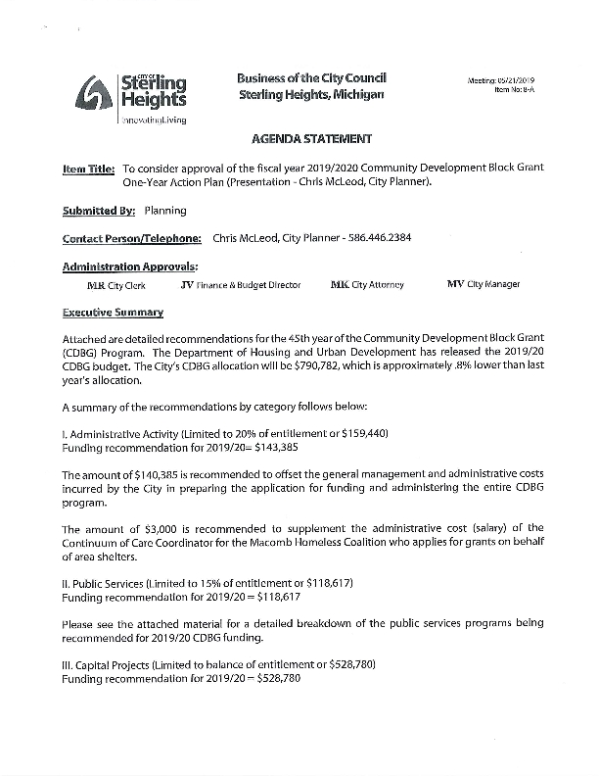
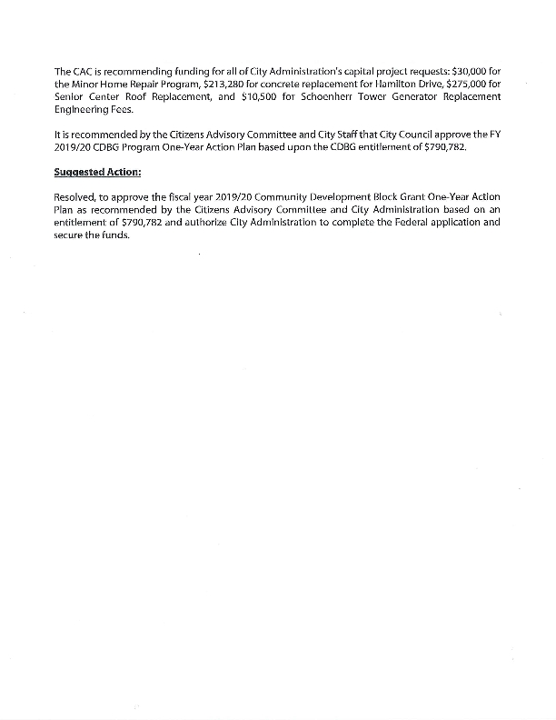
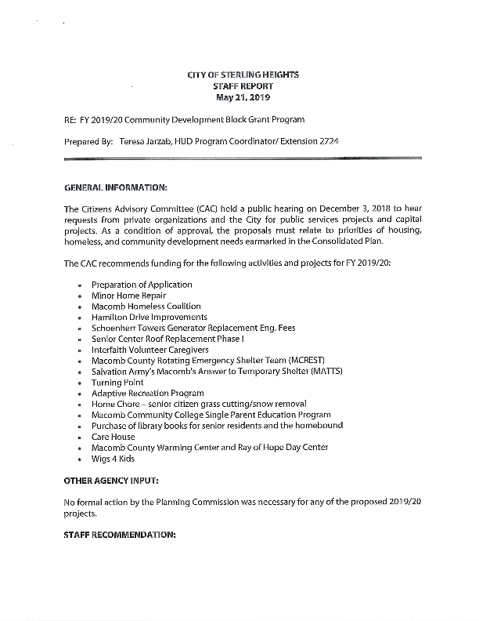
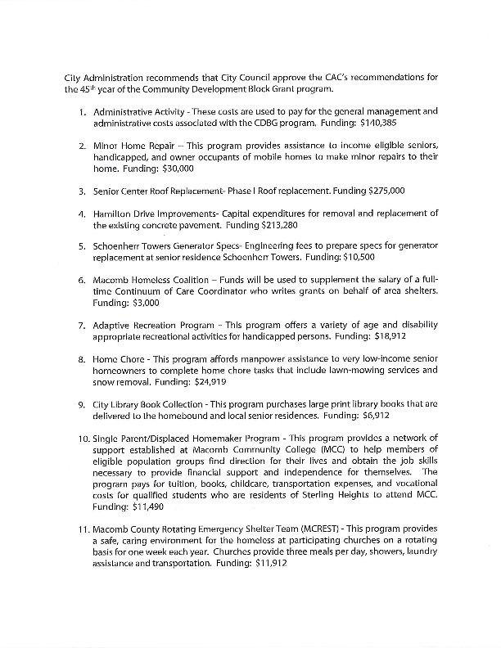
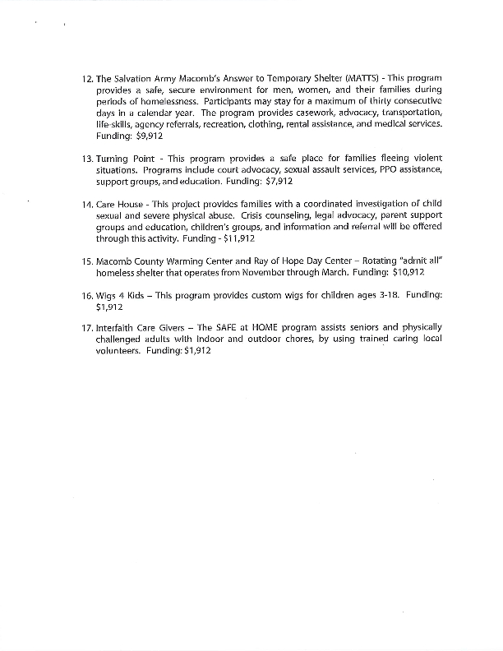
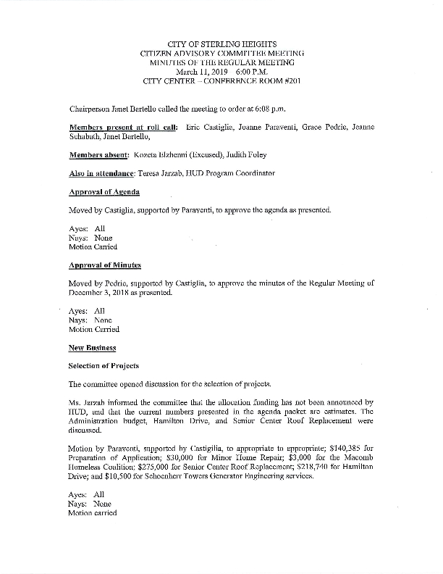
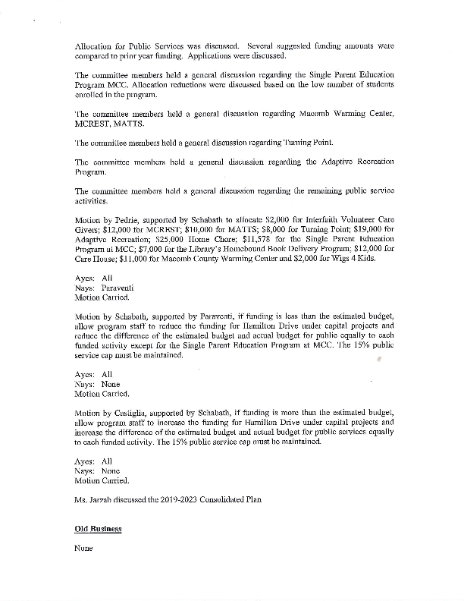
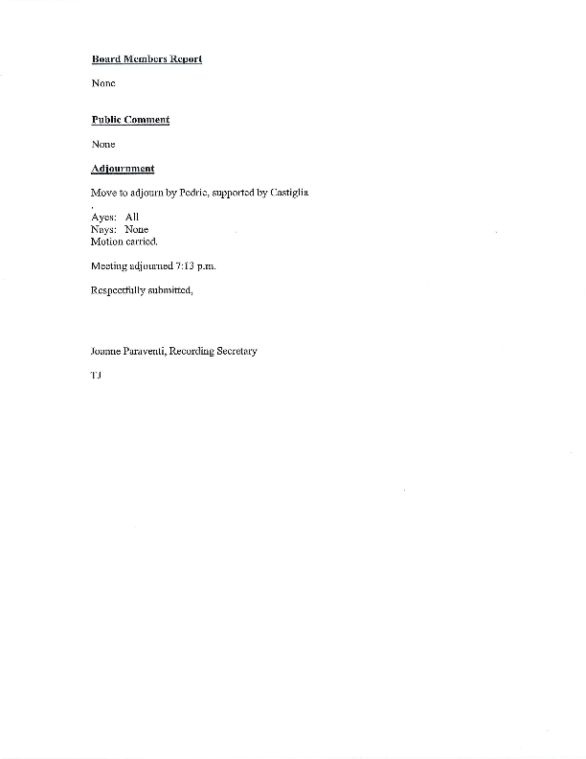
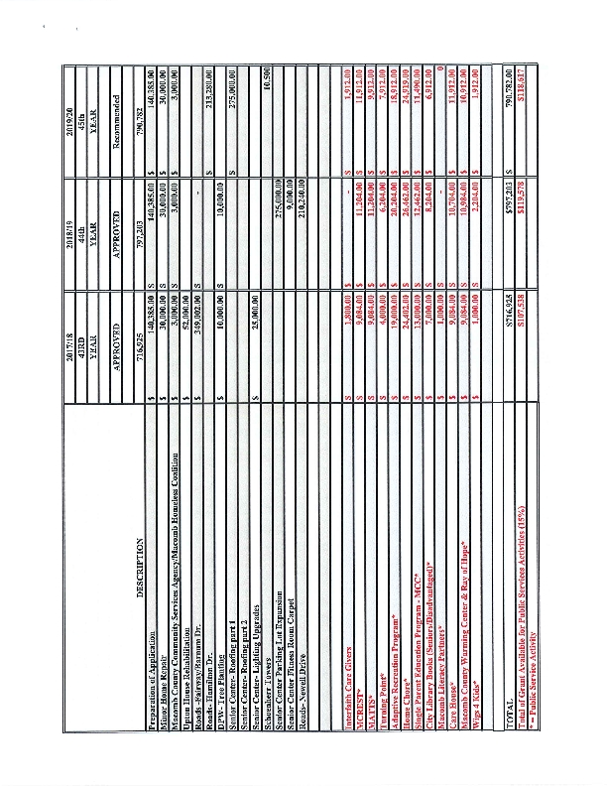

Grantee Unique Appendices
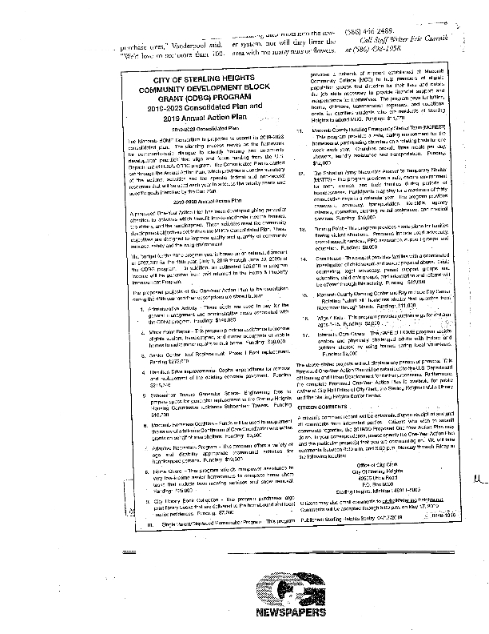
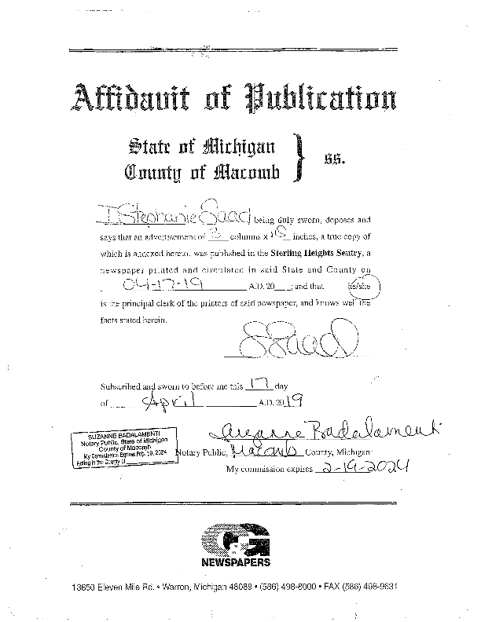

Appendix - Alternate/Local Data Sources

