How do I register for an activity?
- Visit myshpr.net/register
- Click Sign In/Register on the top right corner of the page.
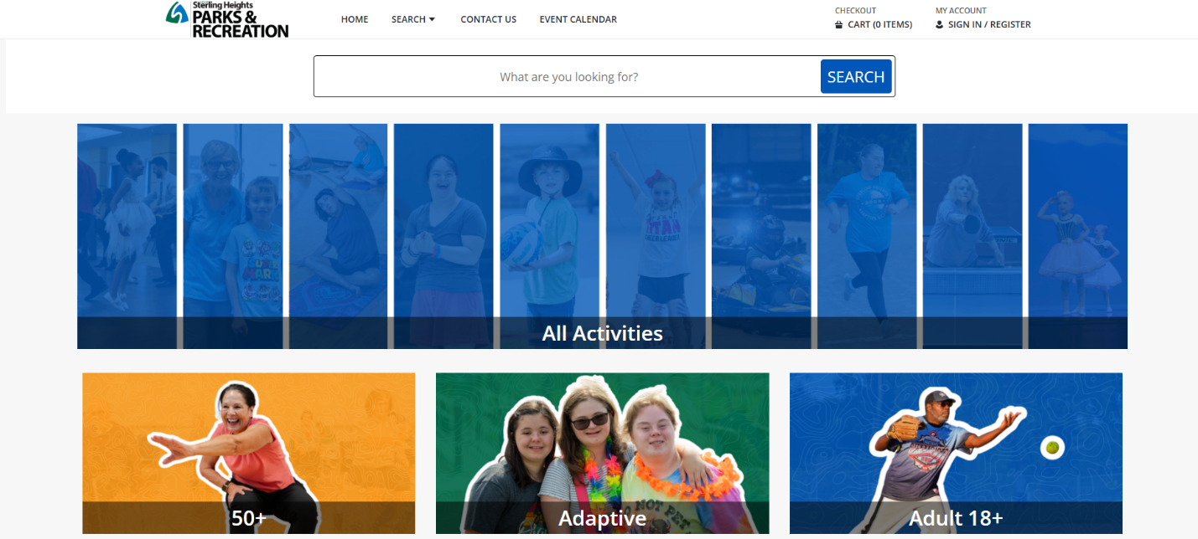

- Log in to your account with your username and password.
  - For help creating an account, please view How do I create an account?
- Use Keyword Search or use filter boxes to locate the program(s) you want.

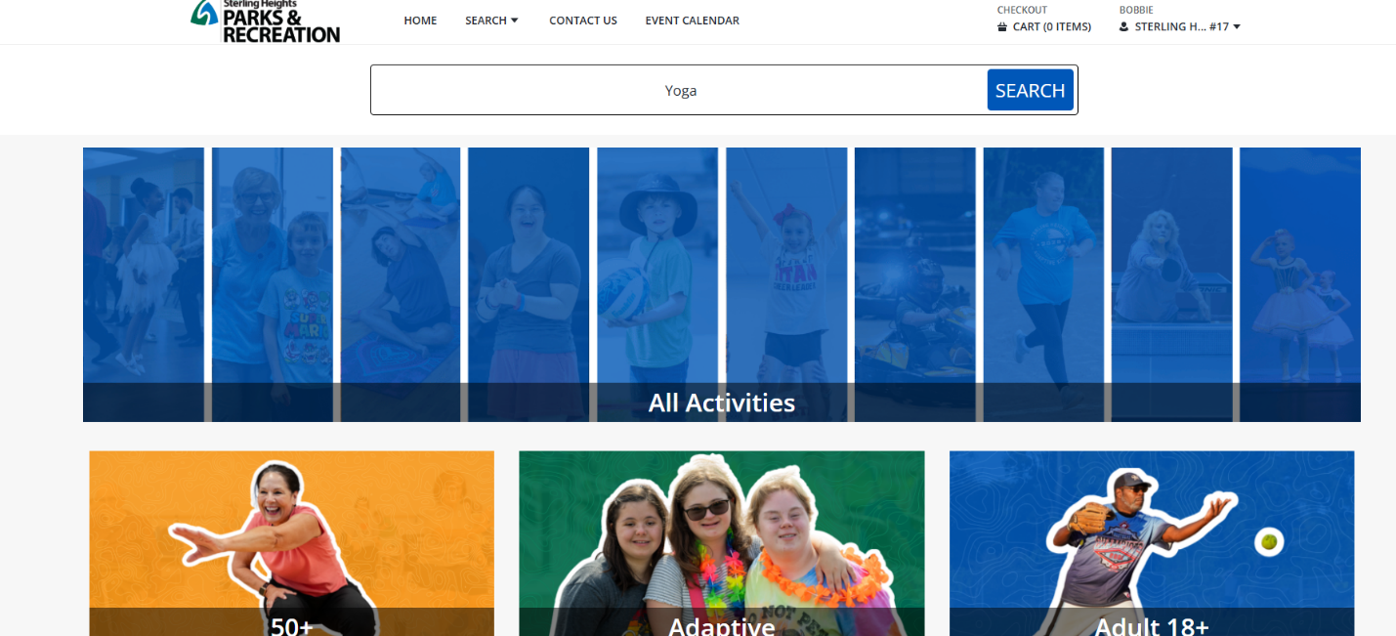

- Click on the activity you want to enroll in and select a section you would like to register for.
  - If the activity is available for registration, it will show as an Available status with a green circle icon on the far right.
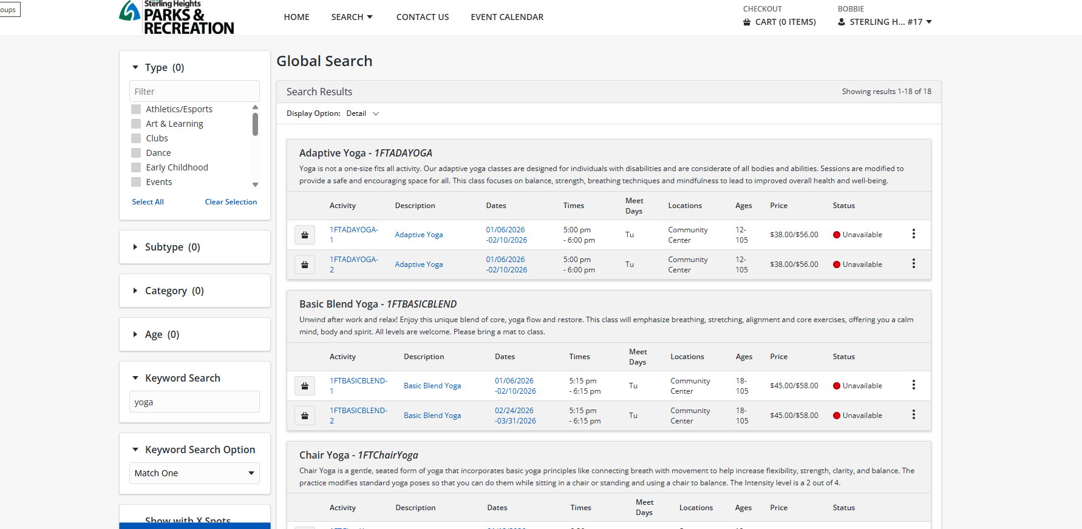

- To add to cart:
  - Option 1: Check the box next to that activity under the Add to Cart heading. You can select multiple activities before adding them to your cart and checking out.
  - Option 2: Click Add to Selection List and then Add to Cart.
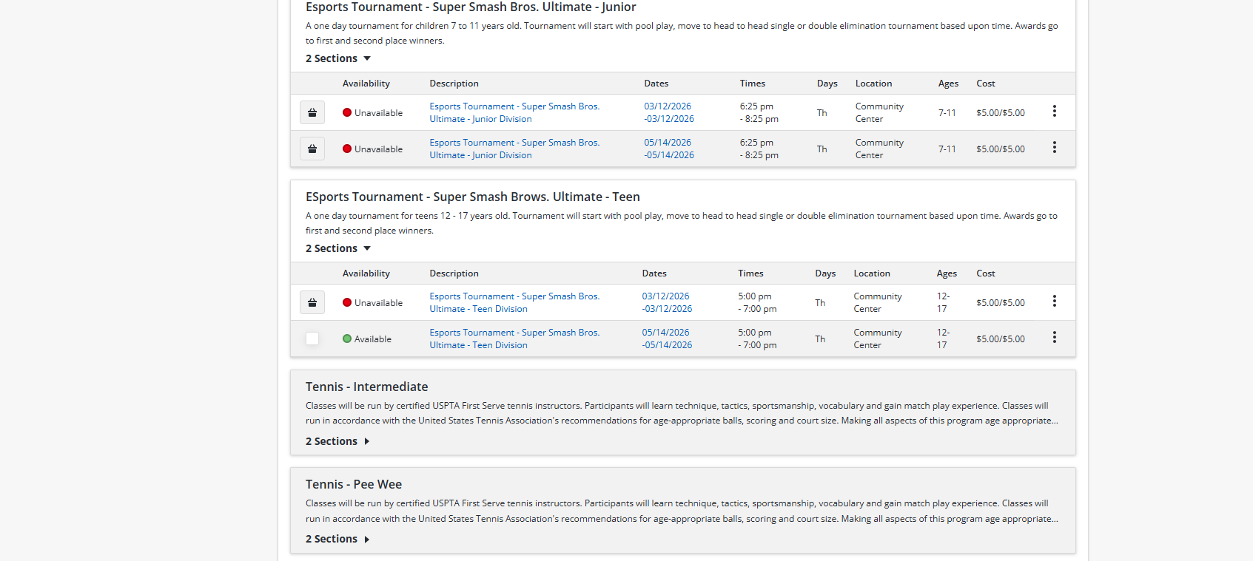

- Check the name(s) of the people who will take the course if in a household. Click Continue.
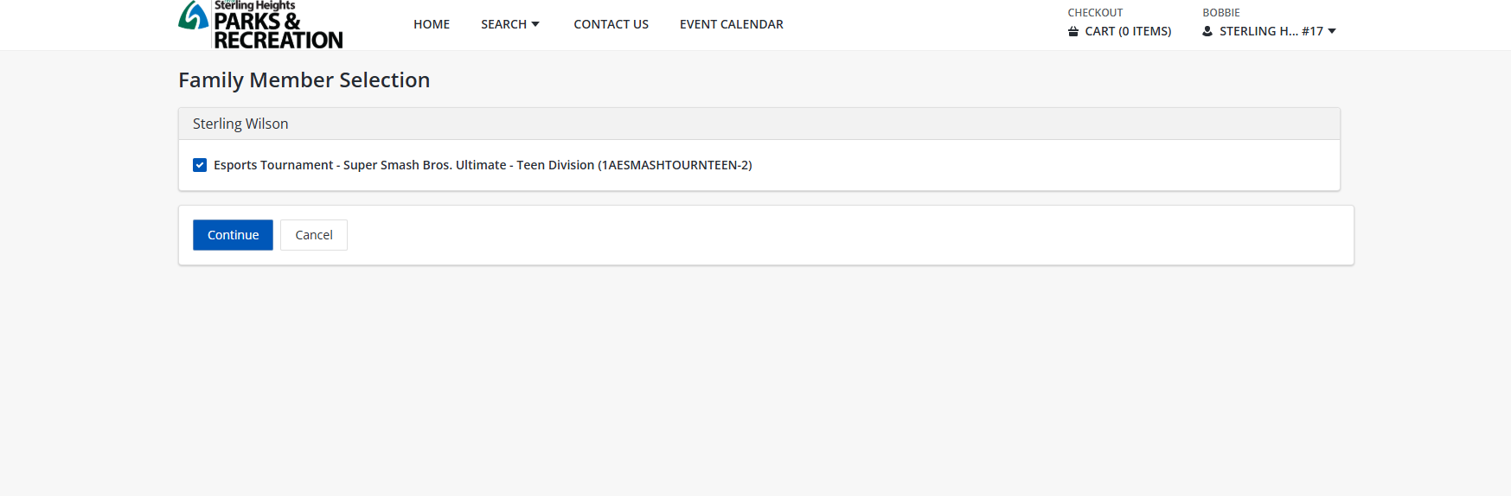

- Answer any questions required.
- Read through the Department of Parks and Recreation Release, Waiver, Hold Harmless, Indemnity and Participation Agreement.
- Click I agree with the above* to sign the online waiver and click Continue.
- Review your cart and click Proceed to Checkout.
- Confirm your billing information.
- Enter your payment information.
- Click Continue to finish checking out.
- Choose to send a copy of your receipt to another email address if you would like.

