Executive Summary

AP-05 Executive Summary - 91.200(c), 91.220(b)
1. Introduction
The City of Sterling Heights has prepared the FY 2021/22 One Year Action Plan which outlines activities that will be funded using Community Development Block Grant (CDBG) and HOME funds received from the United States Department of Housing and Urban Development (HUD) in accordance with 24 CFR Part 91.220 of Title I of the Housing and Community Development Act of 1974, as amended.
The consolidated planning process creates an opportunity for strategic planning and citizen participation to take place in a comprehensive context, and to reduce duplication of effort at the local level. The Consolidated Plan identifies the five-year programmatic goals and activities for the Community Development Block Grant (CDBG). This Con Plan is effective from July 1, 2019 through June 30, 2024, which includes the 2019-2023 program years.

2. Summarize the objectives and outcomes identified in the Plan
This could be a restatement of items or a table listed elsewhere in the plan or a reference to another location. It may also contain any essential items from the housing and homeless needs assessment, the housing market analysis or the strategic plan.
The City of Sterling Heights Community Development Department will strive to provide a public and private cooperative environment leading to effective community development and housing programs and initiatives which meet the needs of people for decent, affordable housing to LMI residents within its jurisdiction, in accordance with the provisions of the National Affordable Housing Act of 1990, as amended. The City of Sterling Heights, anticipates the direct benefit being low and moderate income residents. The Community Development Department staff is committed to meeting the community development and housing needs of the community.

3. Evaluation of past performance
This is an evaluation of past performance that helped lead the grantee to choose its goals or projects.
The City has received CDBG funds since 1974. Throughout this time, the city has allocated the funding to many different sources through public and private initiatives. Throughout this history, it has been determined that providing a public and private collaborative environment, the city is able to leverage the financial resources provided through CDBG will other federal, state and local funds which are available in the community to best meet the needs of low and moderate income residents.
Through an assessment of annual project proposals, the city is able to determine how to use these limited funds to best meet the most urgent needs of residents within the city. This program structure has been determined to work well in the past; as such, the city has determined to continue in this manner over the next five years.
Using the same structure, city staff will continue to promote the collaboration of the city and community organizations in order to meet the needs of city residents given the finite amount of resources that are available. Staff will continue to promote the efficient use of CDBG funds through ongoing technical assistance.

4. Summary of Citizen Participation Process and consultation process
Summary from citizen participation section of plan.
During the preparation of this Annual Action Plan, the city provided multiple community participation and input opportunities. These opportunities consisted of two public collaboration sessions during December 2020 and one public hearing in March 2021. These opportunities were widely advertised through advertisements in the Macomb Daily Newspaper, a newspaper of general circulation in the city, posting to the cities website; letters and emails sent to a vast number of local nonprofit agencies, and churches.
Lastly, a 30-day public comment period was advertised and held from March 24 through May 7, 2021.

5. Summary of public comments
This could be a brief narrative summary or reference an attached document from the Citizen Participation section of the Con Plan.
A summary of the comments received from the focus group and regular meeting minutes, are included as an attachment to this plan.

6. Summary of comments or views not accepted and the reasons for not accepting them
All comments and views submitted in this process were incorporated into the Plan.

7. Summary
Through a comprehensive process which included opportunities for citizen participation and the consultation of many community-based organizations, the City of Sterling Heights has developed this Plan which outlines activities that will be funded using Community Development Block Grant (CDBG) and HOME funds received from the United States Department of Housing and Urban Development (HUD) in accordance with 24 CFR Part 91.220 of Title I of the Housing and Community Development Act of 1974, as amended.

PR-05 Lead & Responsible Agencies - 91.200(b)
1. Agency/entity responsible for preparing/administering the Consolidated Plan
The following are the agencies/entities responsible for preparing the Consolidated Plan and those responsible for administration of each grant program and funding source.
Agency Role | Name | Department/Agency

CDBG Administrator | STERLING HEIGHTS | Neighborhood Services
Table 1 – Responsible Agencies

Narrative
Although the County will be the lead entity responsible for the Consolidated Plan, management of the CDBG programs will be performed by each entitlement community, and coordinated effort of all organizations working in community development will be needed to implement the plan. The City Planning and Community Development Department, other city departments, neighborhood groups, social service agencies, and other organizations serving low-income residents must work together to effectively improve the community. The City Planning and Community Development Department will also be responsible for providing technical assistance to agencies working on community development activities and monitoring the implementation of projects approved in the 20201Action Plan, and the subsequent annual action plans.

Consolidated Plan Public Contact Information
Attn: Teresa Jarzab, HUD Program Coordinator-Sterling Heights
tjarzab@sterling-heights.net - 586-446-2724

AP-10 Consultation - 91.100, 91.200(b), 91.215(l)
1. Introduction
Sterling Heights consulted numerous organizations, planning documents, and other resources during the preparation of the 2021 Annual Action Plan.
Additionally, a public open house was held in the Community, and some additional needs that apply to the community were discussed at other meetings in the 2014 to 2019 Consolidated Plan process. Meetings were well attended by public and assisted housing providers, and private and governmental health, mental health and service agencies.

Provide a concise summary of the jurisdiction’s activities to enhance coordination between public and assisted housing providers and private and governmental health, mental health and service agencies (91.215(l)).
Outreach conducted in this planning process confirmed that the delivery system is strong but is challenged by financial constraints and a great need for eligible activities. The working relationships established between partners are noteworthy, having resulted in the creation of the Consortium, the Macomb Homeless Coalition (MHC), effective interdepartmental cooperation that combines resources to further Program objectives, and inter-agency interventions. The Consortium also meets with the cities of Warren and St. Clair Shores on matters of mutual concern, and the County meets with its Urban County peers for the same purpose.
As reported in the last plan, the system is hindered by time and growing resource constraints, which impede cooperation among partners. Each has its own mandates, making it difficult to achieve the inter-organizational alignment necessary to address shared issues. Another constraint boils down to having insufficient money to address all needs. This forces hard choices between high priority needs and objectives, often diminishing opportunities for cooperation.
The City has a Public Housing Authority which oversees the public housing and Section 8 Voucher programs.

Describe coordination with the Continuum of Care and efforts to address the needs of homeless persons (particularly chronically homeless individuals and families, families with children, veterans, and unaccompanied youth) and persons at risk of homelessness.
The City will continue to work with County and State agencies to encourage shelters and supportive housing. The City does not foresee using its limited funding or resources to provide permanent housing for the homeless.
The City of Sterling Heights and Macomb County participate in a Continum of Care process to develop and implement a coordinated approach to reducing poverty and homelessness. The 2018 Annual Action Plan supports continuing these services as an ongoing priority.
City staff at the subcommittee level along with service organizations, develop and implement a comprehensive plan for emergency shelter and services, transitional and permanent housing. These joint efforts have encouraged a systems approach to homelessness to enable more homeless individuals to achieve self-sufficiency and find jobs and housing in the community.

Describe consultation with the Continuum(s) of Care that serves the jurisdiction’s area in determining how to allocate ESG funds, develop performance standards for and evaluate outcomes of projects and activities assisted by ESG funds, and develop funding, policies and procedures for the operation and administration of HMIS
Sterling Heights does not receive ESG funds

2. Agencies, groups, organizations and others who participated in the process and consultations

Table 2 – Agencies, groups, organizations who participated
1 | Agency/Group/Organization | STERLING HEIGHTS
1 | Agency/Group/Organization Type | Services-Elderly Persons  Other government - Local  Grantee Department
1 | What section of the Plan was addressed by Consultation? | Non-Homeless Special Needs
1 | Briefly describe how the Agency/Group/Organization was consulted. What are the anticipated outcomes of the consultation or areas for improved coordination? | Formal and informal consultation occurred with housing and social service agencies during Plan development.
2 | Agency/Group/Organization | Care House
2 | Agency/Group/Organization Type | Services-Children  Services - Victims
2 | What section of the Plan was addressed by Consultation? | Non-Homeless Special Needs
2 | Briefly describe how the Agency/Group/Organization was consulted. What are the anticipated outcomes of the consultation or areas for improved coordination? | Formal and informal consultation occurred with housing and social service agencies during Plan development. This included the previously mentioned focus group meetings and informal, ad-hoc discussions. As noted, valuable insights were obtained and incorporated into this Plan.
3 | Agency/Group/Organization | Macomb County Interfaith Volunteer Caregivers
3 | Agency/Group/Organization Type | Services-Elderly Persons
3 | What section of the Plan was addressed by Consultation? | Non-Homeless Special Needs
3 | Briefly describe how the Agency/Group/Organization was consulted. What are the anticipated outcomes of the consultation or areas for improved coordination? | Formal and informal consultation occurred with housing and social service agencies during Plan development.
6 | Agency/Group/Organization | Macomb Community College
6 | Agency/Group/Organization Type | Services-Education  Services-Employment  Other government - State
6 | What section of the Plan was addressed by Consultation? | Non-Homeless Special Needs  Economic Development
6 | Briefly describe how the Agency/Group/Organization was consulted. What are the anticipated outcomes of the consultation or areas for improved coordination? | Formal and informal consultation occurred with housing and social service agencies during Plan development.
7 | Agency/Group/Organization | Salvation Army MATTS Shelter
7 | Agency/Group/Organization Type | Services-homeless
7 | What section of the Plan was addressed by Consultation? | Public Housing Needs  Homeless Needs - Chronically homeless  Homeless Needs - Families with children  Homelessness Needs - Veterans  Homelessness Needs - Unaccompanied youth  Homelessness Strategy
7 | Briefly describe how the Agency/Group/Organization was consulted. What are the anticipated outcomes of the consultation or areas for improved coordination? | Formal and informal consultation occurred with housing and social service agencies during Plan development.
8 | Agency/Group/Organization | MCREST
8 | Agency/Group/Organization Type | Services-homeless
8 | What section of the Plan was addressed by Consultation? | Homeless Needs - Chronically homeless  Homeless Needs - Families with children  Homelessness Needs - Veterans  Homelessness Strategy
8 | Briefly describe how the Agency/Group/Organization was consulted. What are the anticipated outcomes of the consultation or areas for improved coordination? | Formal and informal consultation occurred with housing and social service agencies during Plan development.
10 | Agency/Group/Organization | Turning Point
10 | Agency/Group/Organization Type | Services-Victims of Domestic Violence  Services-homeless  Services-Health  Services-Education  Services-Employment  Services - Victims
10 | What section of the Plan was addressed by Consultation? | Homeless Needs - Families with children
10 | Briefly describe how the Agency/Group/Organization was consulted. What are the anticipated outcomes of the consultation or areas for improved coordination? | Formal and informal consultation occurred with housing and social service agencies during Plan development.
11 | Agency/Group/Organization | Maggie's Wigs 4 Kids
11 | Agency/Group/Organization Type | Services-Children
11 | What section of the Plan was addressed by Consultation? | Non-Homeless Special Needs
11 | Briefly describe how the Agency/Group/Organization was consulted. What are the anticipated outcomes of the consultation or areas for improved coordination? | Formal and informal consultation occurred with housing and social service agencies during Plan development.

Identify any Agency Types not consulted and provide rationale for not consulting

Other local/regional/state/federal planning efforts considered when preparing the Plan
Name of Plan | Lead Organization | How do the goals of your Strategic Plan overlap with the goals of each plan?
Continuum of Care | Macomb Homeless Coalition | The 10 year plan to end homelessness align with the goals and strategies of the Consolidated Plan and Annual Action Plan
Table 3 - Other local / regional / federal planning efforts

Narrative

AP-12 Participation - 91.401, 91.105, 91.200(c)
1. Summary of citizen participation process/Efforts made to broaden citizen participation
Summarize citizen participation process and how it impacted goal-setting

The Citizens Advisory Committee held several meetings to obtain citizen input on proposed projects. A selection of projects meeting was held March 15, 2021. No citizen comments were received.
The City of Sterling Heights is required to set forth policies and procedures for citizen participation in the process of developing and implementing the Consolidated Plan and all its components. In accordance with federal regulation 24 CFR 91.105, Sterling Heights maintains a Citizen Participation Plan (CPP). The CPP applies to CDBG, and HOME programs as well as to the development and implementation of the Consolidated and Annual Action Plan. The CPP outlines the policies and procedures used by the City to solicit citizen input. The City followed the CPP in the development of the 2019-2023 Consolidated Plan. CPP requires the City to conduct one public hearing for citizens, and one additional focus group meetings with non-housing, and housing agencies, concerning the Consolidated Plan and other basic program requirements. The City encourages participation in the Consolidated Plan process. The City's 2019-2023 Consolidated Plan citizen participation efforts included the following efforts to achieve maximum feasible public participation: Advertised citizen participation opportunities in local newspaper, and online. Encouraged participation by holding events at accessible locations. Mailed survey and workshop flyers to members of the local Continuum of Care and Public Housing Authorities through the Macomb HOME Consortium. Distributed surveys to expand public participation through the Macomb HOME Consortium. The City considers comments from citizens, service organizations and internal departments, received in writing or verbally at public hearings in preparing the final Consolidated Plan. The plan is then made available for 30 days for additional public comment before final approval by the City Council.

Citizen Participation Outreach
Sort Order | Mode of Outreach | Target of Outreach | Summary of  response/attendance | Summary of  comments received | Summary of comments not accepted and reasons | URL (If applicable)
1 | Public Meeting | Non-targeted/broad community |  | No citizen comments were received.
2 | Newspaper Ad | Non-targeted/broad community |  | No citizen comments were received.
Table 4 – Citizen Participation Outreach

Expected Resources

AP-15 Expected Resources - 91.420(b), 91.220(c)(1,2)
Introduction
The City receives Program income from lien payoffs of houses that have been rehabilitated with CDBG funds. These funds are receipted back to the Rehab program to be used again. Program income for the last 5 years has averaged $50,000. Recently there has been a spike in program payoffs.

Anticipated Resources
Program | Source of Funds | Uses of Funds | Expected Amount Available Year 1 |  |  |  | Expected Amount Available Remainder of ConPlan  $ | Narrative Description
Program | Source of Funds | Uses of Funds | Annual Allocation: $ | Program Income: $ | Prior Year Resources: $ | Total:  $ | Expected Amount Available Remainder of ConPlan  $ | Narrative Description
CDBG | public - federal | Acquisition  Admin and Planning  Economic Development  Housing  Public Improvements  Public Services | 808,389 | 0 | 0 | 808,389 | 0 | These funds will leverage other public investment through infrastructure projects.
Table 1 - Expected Resources – Priority Table

Explain how federal funds will leverage those additional resources (private, state and local funds), including a description of how matching requirements will be satisfied
Community Development Block Grant funds will leverage additional resources as follows:
- Public Infrastructure & public facility projects will be supported with other funds from participating jurisdictions
- Rehabilitation funds will leverage Weatherization and other sources to expand the scope of rehabilitation assistance
HOME Investment Partnership Funds will leverage additional public and private investment:
- Homeownership investment will leverage funds from other agencies such as the Michigan State Housing Development Authority and other funds
- Rental projects supported by HUD will leverage additional funding from Federal Home Loan Bank programs
Income Housing Tax Credits and corresponding private equity investment, private construction and acquisition financing; and other sources
- HOME match requirements are achieved via in-kind support of numerous agencies, the donation of labor and materials on numerous homeowner projects, and the application of payments in lieu of taxes for affordable housing developments in numerous communities

If appropriate, describe publically owned land or property located within the jurisdiction that may be used to address the needs identified in the plan
The City will address needs of roads in identified low/moderate areas of the City. Improvements to public facilities serving LMI are included with the 2021 program
Discussion
The City Planning reviews capital projects for determing which will provide the most benefit to the community.

Annual Goals and Objectives
AP-20 Annual Goals and Objectives - 91.420, 91.220(c)(3)&(e)
Goals Summary Information
Sort Order | Goal Name | Start Year | End Year | Category | Geographic Area | Needs Addressed | Funding | Goal Outcome Indicator
1 | Make Available Appropriate Housing | 2019 | 2023 | Affordable Housing  Public Housing  Homeless | Low Mod Census Tracks  Low Mod Residents | Housing Rehabilitation  Affodable Housing Units  Permanent Supportive Housing  Emergency Shelters and Transitional Housing  Accessibility/Barrier Free Improvements | CDBG: $30,000 | Homeowner Housing Rehabilitated: 5 Household Housing Unit
2 | Address the Needs of Homeless & At-Risk Families | 2019 | 2023 | Homeless | Low Mod Residents | Permanent Supportive Housing  Emergency Shelters and Transitional Housing  Public Services | CDBG: $20,320 | Homeless Person Overnight Shelter: 150 Persons Assisted
3 | Foster Economic Development | 2019 | 2023 | Non-Housing Community Development | Low Mod Residents | Public Services | CDBG: $10,160 | Public service activities other than Low/Moderate Income Housing Benefit: 10 Persons Assisted
4 | Improve Public Facilities and Infrastructure | 2019 | 2023 | Non-Housing Community Development | Low Mod Census Tracks  Low Mod Residents | Public Improvements  Public Facilities  Senior and Youth Facilities and Services  Public Services  Accessibility/Barrier Free Improvements  Code Enforecement & Crime Prevention | CDBG: $509,131 | Public service activities other than Low/Moderate Income Housing Benefit: 1500 Persons Assisted
5 | Provide and Expand Human Services | 2019 | 2023 | Homeless  Non-Homeless Special Needs  Non-Housing Community Development | Low Mod Census Tracks  Low Mod Residents | Public Facilities  Senior and Youth Facilities and Services | CDBG: $89,497 | Public Facility or Infrastructure Activities other than Low/Moderate Income Housing Benefit: 1150 Persons Assisted
6 | Aid the Prevention of Slums and Blight | 2019 | 2023 | Non-Housing Community Development | Low Mod Census Tracks | Code Enforecement & Crime Prevention | CDBG: $0 | Housing Code Enforcement/Foreclosed Property Care: 50 Household Housing Unit
7 | Expand Planning, Grant Management and Capacity | 2019 | 2023 | Grant Administion | Low Mod Census Tracks  Low Mod Residents | Local and Regional Planning | CDBG: $148,000 | Other: 1 Other
Table 2 – Goals Summary

Goal Descriptions

1 | Goal Name | Make Available Appropriate Housing
1 | Goal Description | The priority needs were determined through public outreach and coordination with local agencies and service providers. The Consortium anticipates addressing these needs through program funding during the 2021 to 2022 planning cycle
2 | Goal Name | Address the Needs of Homeless & At-Risk Families
2 | Goal Description | The priority needs were determined through public outreach and coordination with local agencies and service providers. The Consortium anticipates addressing these needs through program funding during the 2021 to 2022 planning cycle.
3 | Goal Name | Foster Economic Development
3 | Goal Description | The priority needs were determined through public outreach and coordination with local agencies and service providers. The Consortium anticipates addressing these needs through program funding during the 2021 to 2022 planning cycle.
4 | Goal Name | Improve Public Facilities and Infrastructure
4 | Goal Description | The priority needs were determined through public outreach and coordination with local agencies and service providers. The Consortium anticipates addressing these needs through program funding during the 2021 to 2022 planning cycle.
5 | Goal Name | Provide and Expand Human Services
5 | Goal Description | The priority needs were determined through public outreach and coordination with local agencies and service providers. The Consortium anticipates addressing these needs through program funding during the 2021 to 2022 planning cycle.
6 | Goal Name | Aid the Prevention of Slums and Blight
6 | Goal Description | The priority needs were determined through public outreach and coordination with local agencies and service providers. The Consortium anticipates addressing these needs through program funding during the 2021 to 2022 planning cycle.
7 | Goal Name | Expand Planning, Grant Management and Capacity
7 | Goal Description | The priority needs were determined through public outreach and coordination with local agencies and service providers. The Consortium anticipates addressing these needs through program funding during the 2021 to 2022 planning cycle

AP-35 Projects - 91.420, 91.220(d)
Introduction
The proposed projects of the First Year Action Plan are intended to be in direct line with the goals and strategy of the 5-Year Consolidated Plan. Through a community application process, the city has been able to identify the following projects which will directly work to meet the objectives, goals and strategies of the Consolidated Plan. These activities target the priority needs of the community while also meeting the statutory goals of the CDBG program.

# | Project Name
1 | Administration
2 | Housing Rehabilitation
3 | Public Service
4 | Public Improvements
Table 3 – Project Information

Describe the reasons for allocation priorities and any obstacles to addressing underserved needs

AP-38 Project Summary
Project Summary Information

1 | Project Name | Administration
1 | Target Area | Low Mod Census Tracks  Low Mod Residents
1 | Goals Supported | Expand Planning, Grant Management and Capacity
1 | Needs Addressed | Local and Regional Planning
1 | Funding | CDBG: $148,000
1 | Description | Program Administration
1 | Target Date | 6/30/2022
1 | Estimate the number and type of families that will benefit from the proposed activities
1 | Location Description | Planning is City-wide
1 | Planned Activities
2 | Project Name | Housing Rehabilitation
2 | Target Area | Low Mod Census Tracks  Low Mod Residents
2 | Goals Supported | Make Available Appropriate Housing
2 | Needs Addressed | Housing Rehabilitation
2 | Funding | CDBG: $30,000
2 | Description | This program provides assistance to income eligible seniors, handicapped, and owner occupants of mobile homes to make minor repairs to their homes.
2 | Target Date | 6/30/2022
2 | Estimate the number and type of families that will benefit from the proposed activities
2 | Location Description
2 | Planned Activities
3 | Project Name | Public Service
3 | Target Area | Low Mod Census Tracks  Low Mod Residents
3 | Goals Supported | Address the Needs of Homeless & At-Risk Families  Provide and Expand Human Services  Foster Economic Development  Aid the Prevention of Slums and Blight
3 | Needs Addressed | Public Services
3 | Funding | CDBG: $121,258
3 | Description | Public services that provide assistance to Seniors, low income, homeless, as well as abused children.
3 | Target Date | 6/30/2022
3 | Estimate the number and type of families that will benefit from the proposed activities
3 | Location Description
3 | Planned Activities
4 | Project Name | Public Improvements
4 | Target Area | Low Mod Census Tracks
4 | Goals Supported | Improve Public Facilities and Infrastructure
4 | Needs Addressed | Public Improvements
4 | Funding | CDBG: $509,131
4 | Description | Public Facility improvements including road improvements in LMA, and Senior living facility improvements.
4 | Target Date | 6/30/2022
4 | Estimate the number and type of families that will benefit from the proposed activities
4 | Location Description
4 | Planned Activities

AP-50 Geographic Distribution - 91.420, 91.220(f)
Description of the geographic areas of the entitlement (including areas of low-income and minority concentration) where assistance will be directed
Sterling Heights will be assisting low-mod residents in the entire community. Given the fact that most of the low-income population within the city is located throughout different census tracts, the city has determined that funding should be available community-wide, to best meet the needs of low-income residents. The city does not contain any concentrations of minority populations.

Geographic Distribution
Target Area | Percentage of Funds
Low Mod Census Tracks | 50
Low Mod Residents | 50
Table 4 - Geographic Distribution

Rationale for the priorities for allocating investments geographically
As mentioned above, given the fact that most of the low-income population within the city is located throughout different census tracts, the city has determined that funding should be available community- wide to best meet the needs of low-income residents.

Discussion
Areas of focused funding will continued to be reviewed in future years in order to determine whether or not a sufficient need exists in one specific area of the community which warrants the need for concentrated funding. At this time, the city has not identified any specific areas.

AP-75 Barriers to affordable housing -91.420, 91.220(j)
Introduction
The single greatest barrier to affordable housing in the City of Sterling Heights is the cost of land and housing.

The preservation of affordable housing options in the City of Sterling Heights is part of the Consolidated Plan- Make Available Appropriate Housing: The maintenance and preservation of housing for all residents but particularly affordable housing for Low/Mod income owners is a high priority in this plan. To achieve this objective the City has an established housing rehab program, minor home repair, and home chore programs.

Planned actions include:
- Implement its housing activities in a fair and equitable manner as required by law.
- Continue collaborative efforts with housing providers to promote affordable home ownership and rental housing opportunities for LMI households.
- Support, if possible, other reasonable proposals for affordable housing.

Actions it planned to remove or ameliorate the negative effects of public policies that serve as barriers to affordable housing such as land use controls, tax policies affecting land, zoning ordinances, building codes, fees and charges, growth limitations, and policies affecting the return on residential investment
The City plans to implement its housing activities in a fair and equitable manner as required by law, continue collaborative efforts with housing providers to promote both affordable home ownership and housing opportunities, support, if possible reasonable proposals for affordable housing. In an effort to address the housing affordability issues, the City of Sterling Heights, along with Macomb County, the City of Roseville, and the Charter Township of Clinton, have formed a HOME Consortium, which will continue to strengthen existing relationships and build new relationships in its effort to increase affordable housing opportunities in the Consortium boundaries.

Discussion
The City is committed to improving or removing barriers to affordable housing. Staff will continue to evaluate barriers identified in the Analysis of Impediments to Fair Housing.
Additionally, HOME funds have been allocated for acquisition/rehab/resale

AP-85 Other Actions - 91.420, 91.220(k)
Introduction
Through a competitive application process, the city has selected the proposed activities, which best meet, the most urgent needs of the community. While use of CDBG funding is limited to only eligible activities, the city will work using additional local funds to work to meet the affordable housing needs of the city.

Actions planned to address obstacles to meeting underserved needs
Through the application process, many community-based organizations were able to present requests for meeting the underserved needs within the community. The city, through city staff, the Housing Commission, and City Council, was able to determine the needs that are the most urgent and underserved. The proposed activities have been selected to meet the most underserved needs within the community.

Actions planned to foster and maintain affordable housing
Through grant and loan programs, home repair assistance will be provided to low-income households in order to preserve the existing affordable housing stock within the city.

Actions planned to reduce lead-based paint hazards
Sterling Heights currently complies with all federal regulations regarding lead-based paint. Full compliance is a policy of the housing rehabilitation program administered by the city. The program is administered in a way which ensures the procedures follow the policy in order to ensure full compliance.

Actions planned to reduce the number of poverty-level families
Through community partners increase public awareness of poverty, its causes and effects, the resources available to those impacted by it, and the actions that can be taken to combat it
Actions planned to develop institutional structure
Sterling Heights will make a continued effort to improve services and service delivery, to customer, employees and partners in the community.

Actions planned to enhance coordination between public and private housing and social service agencies
As previously indicated, coordination between the public and private housing and social service agencies is of paramount importance to the success of this plan. The city will continue to work to further develop these relationships.

Discussion
Through community collaboration between the public and private sector, the city will work through the mentioned activities to best meet the needs of low and moderate income residents. The first year plan will follow the goals and objectives identified within the strategic plan.

Program Specific Requirements
AP-90 Program Specific Requirements - 91.420, 91.220(l)(1,2,4)
Introduction

Community Development Block Grant Program (CDBG)
Reference 24 CFR 91.220(l)(1)
Projects planned with all CDBG funds expected to be available during the year are identified in the Projects Table. The following identifies program income that is available for use that is included in projects to be carried out.

1. The total amount of program income that will have been received before the start of the next program year and that has not yet been reprogrammed | 0
2. The amount of proceeds from section 108 loan guarantees that will be used during the year to address the priority needs and specific objectives identified in the grantee's strategic plan. | 0
3. The amount of surplus funds from urban renewal settlements | 0
4. The amount of any grant funds returned to the line of credit for which the planned use has not been included in a prior statement or plan | 0
5. The amount of income from float-funded activities | 0
Total Program Income: | 0

Other CDBG Requirements
1. The amount of urgent need activities | 0

2. The estimated percentage of CDBG funds that will be used for activities that benefit persons of low and moderate income.Overall Benefit - A consecutive period of one, two or three years may be used to determine that a minimum overall benefit of 70% of CDBG funds is used to benefit persons of low and moderate income. Specify the years covered that include this Annual Action Plan. | 95.00%

Discussion

Attachments

Citizen Participation Comments
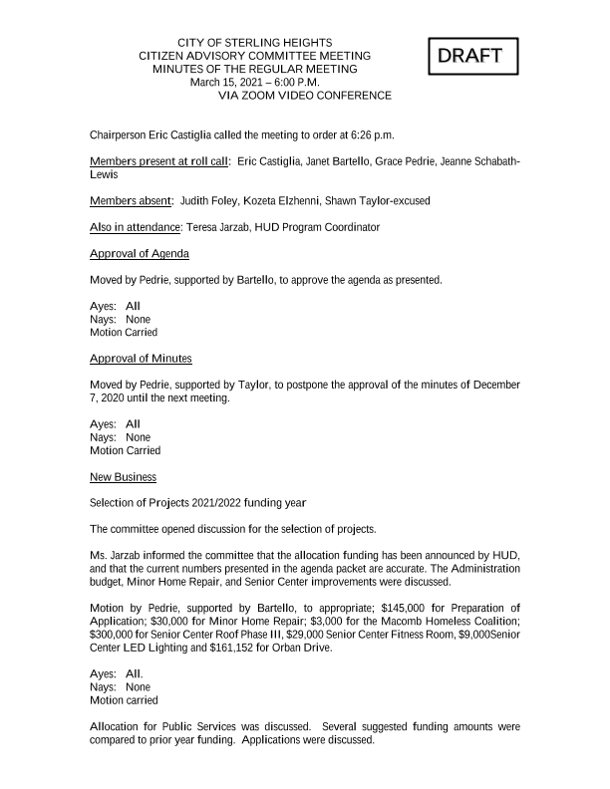
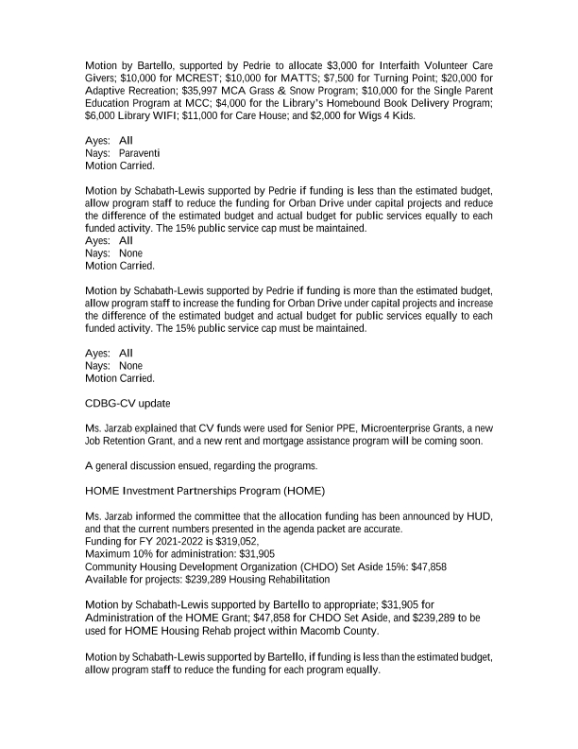
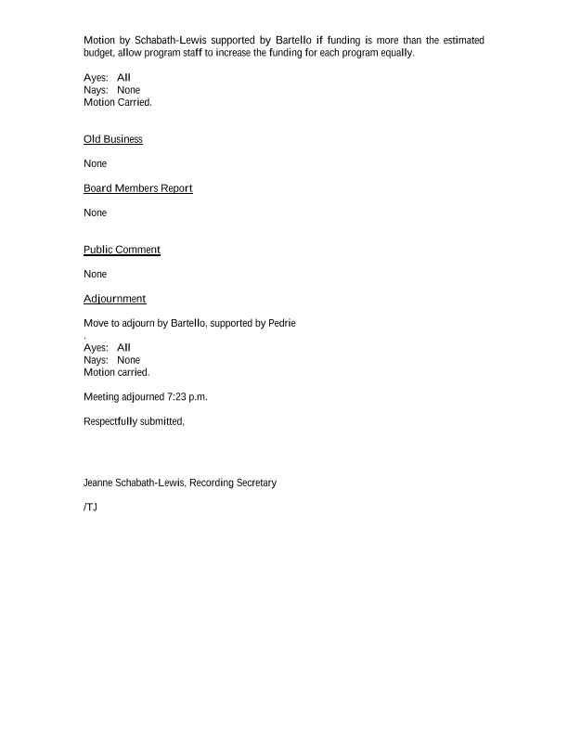
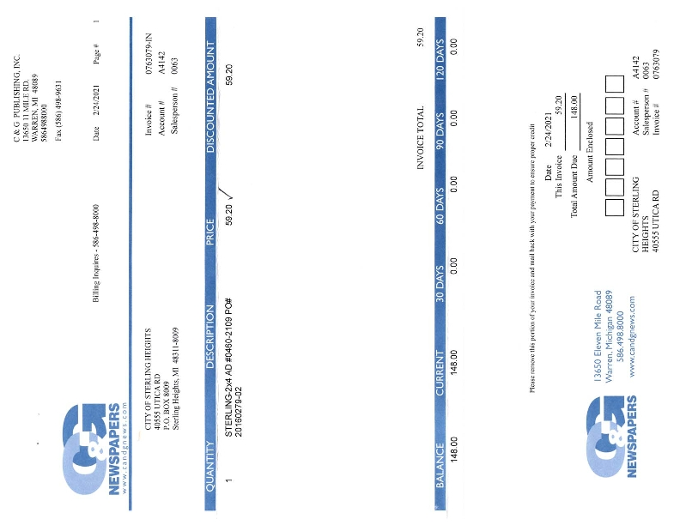
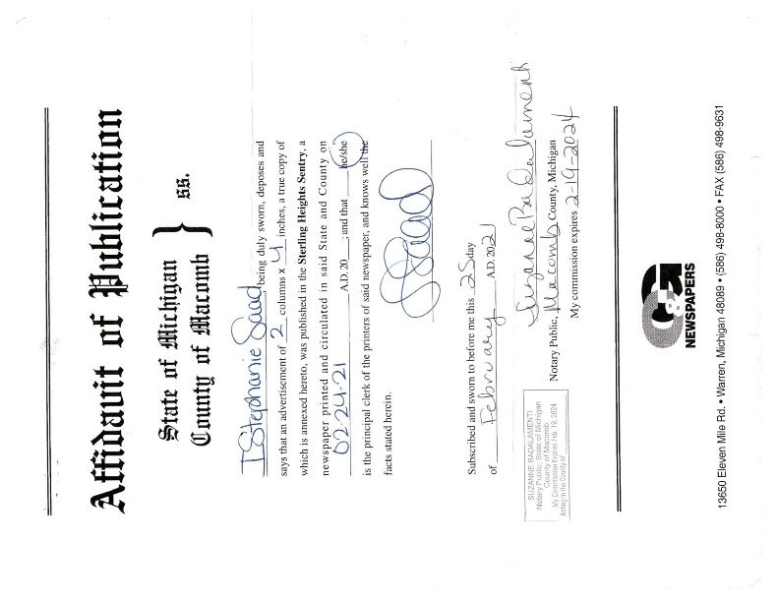
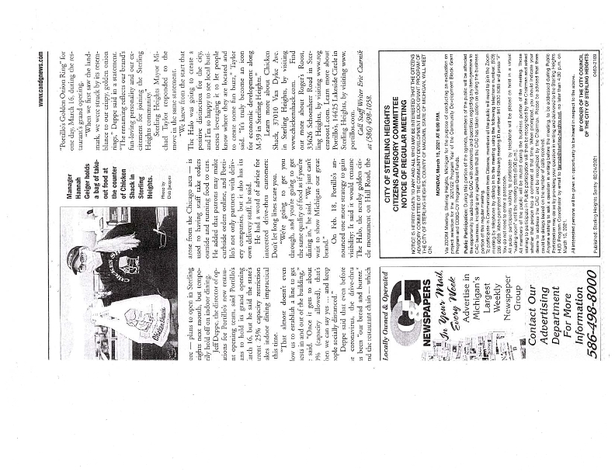
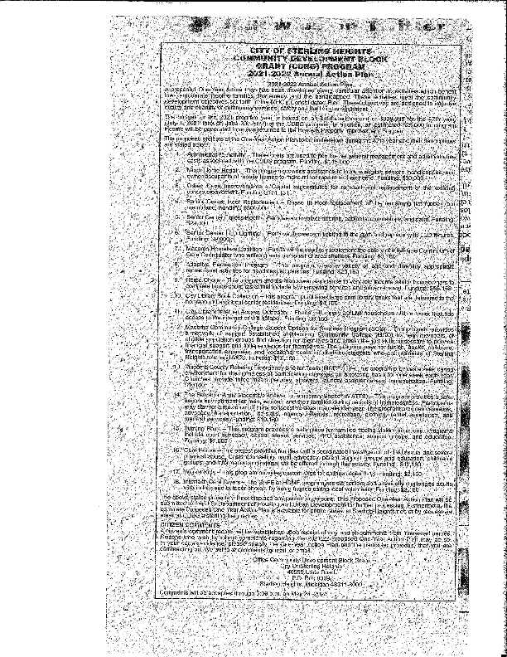
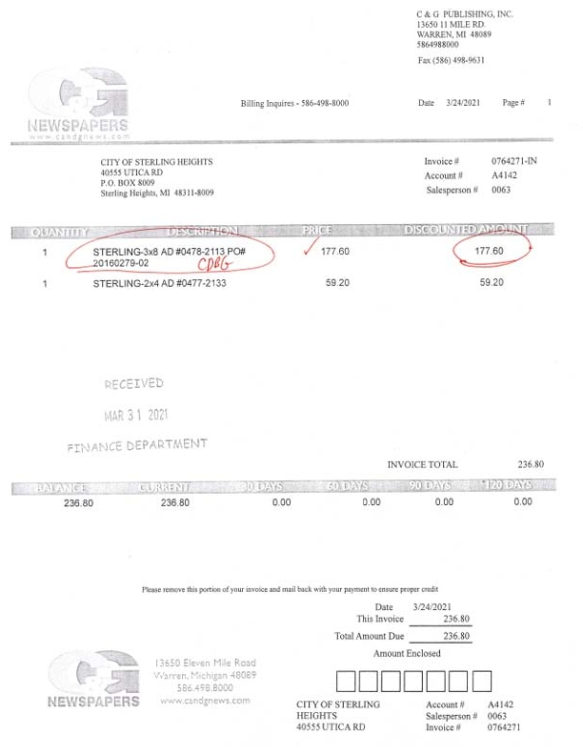
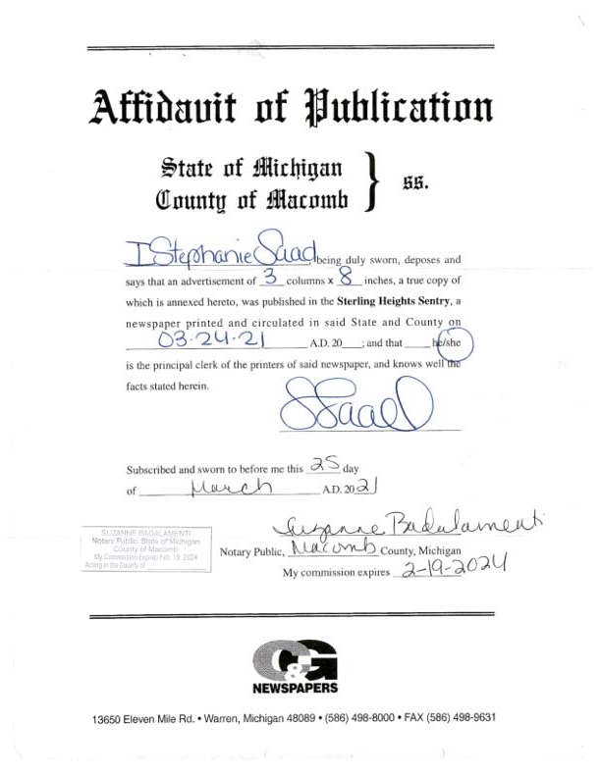
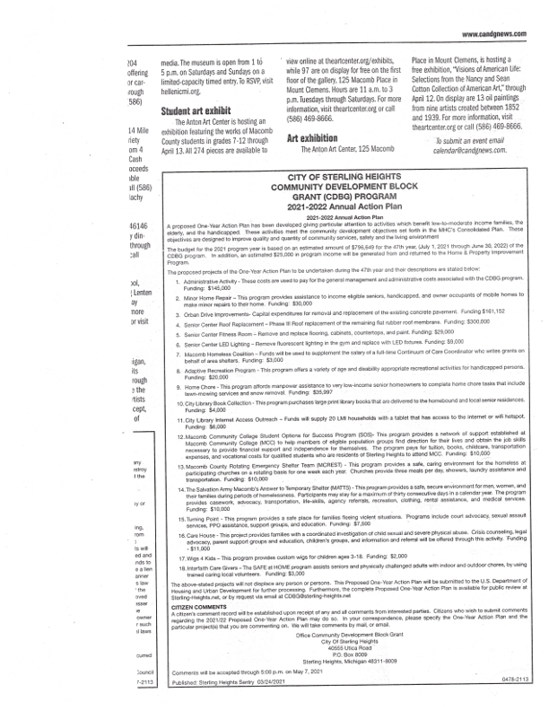

Grantee SF-424's and Certification(s)
